Kumtor Gold Company CJSC invites interested parties to participate in an unrestricted two-envelope tender for the refurbishment of the desorption column heat exchanger
Submission format: | The tender proposal and other documents must be signed by a person authorized to sign the proposal and assume obligations under the Agreement. The documents must bear the company seal and be submitted in PDF format. The signatory’s authority must be supported by a power of attorney or certified copies of the relevant documents.  Before preparing the tender proposal, the bidder must review the Instructions for Preparing a Tender Proposal (for Suppliers) (Appendix 1).
Proposal submission procedure | Bidders must submit their proposals in Russian in accordance with the tender requirements, attach the required document copies, and email them to teplo2026@kumtor.kg by 5:00 p.m. (Bishkek time) on 22 October 2026.  The tender will be conducted in two stages, and a separate email must be prepared for each stage:  The first email (for Stage 1) must contain documents supporting the qualification and technical parts. The subject line must read “Qualification Documents”;  The second email (for Stage 2) must contain the financial proposal.  The subject line must read “Financial Documents”;  The Terms of Reference and inspection report are attached:  Services for refurbishment of the desorption column heat exchanger (Appendices 8 and 9).
 | Stage 1: Qualification and Technical Part
The proposal must include the following documents: | For residents:  A letter confirming interest in participating in the tender; the application form is attached (Appendix 2).
The proposal must include the following documents: | A scanned copy of the legal entity registration certificate.
The proposal must include the following documents: | A scanned copy of the document defining the principal activity (Charter), and a scanned copy of the resolution appointing the head of the entity.
The proposal must include the following documents: | Scanned copies of the original financial statements for 2024–2025:  · Balance Sheet;  · Profit and Loss Statement;  · Cash Flow Statement;  · Statement of Changes in Equity;  · Or the Unified Tax Return for 2024–2025.
The proposal must include the following documents: | References and feedback on performance under previous contracts.
The proposal must include the following documents: | Integrity Declaration, form attached (Appendix 3).
The proposal must include the following documents: | Tender Proposal Security Declaration, form attached (Appendix 4).
The proposal must include the following documents: | Information on employees, including their previous work experience. Form attached (Appendix 5).
The proposal must include the following documents: | List of business partners with a brief description of previously completed work and references. Form attached (Appendix 5).
For non-residents: | - Letter confirming interest in participating in the tender, application form attached (Appendix 2)  - Scanned copy of the legal entity registration certificate  - Scanned copy of the document defining the principal activity (Charter)  - Scanned copy of the resolution appointing the head of the entity  - Document confirming financial stability for 2024–2025  - References and feedback on performance under previous contracts  - Integrity Declaration, form attached (Appendix 3)  - Tender Proposal Security Declaration, form attached (Appendix 4)  - Information on employees, including their previous work experience. Form attached (Appendix 5)  - List of business partners with a brief description of previously completed work and references. Form attached (Appendix 5)
Stage 1 evaluation criteria: | A proposal that meets all qualification requirements and includes the complete set of requested documents will be deemed to have passed Stage 1.  Bidders must provide all documents required to confirm their qualifications in accordance with the Terms of Reference.
Financial proposal submission procedure | Stage 2: Financial Part of the Proposal:
The financial/commercial proposal must be submitted in a password-protected archive; the application form is attached (Appendix 7). The password must be provided upon request by the person responsible for this tender.
The archive password must contain at least 8 characters, including 1 number, 1 special character, at least one uppercase letter, and at least one lowercase letter. The financial/commercial proposal must be on the bidder’s official letterhead, addressed to Kumtor Gold Company CJSC, and must specify the price, completion period, and payment terms.
Passwords will be requested only from bidders that meet the qualification and technical requirements.

If the financial/commercial proposal is submitted without password protection or together with the qualification documents, the tender committee of the procuring organization will not be liable for the confidentiality of the information.
Pricing requirements | Prices for the work must be provided as a commercial proposal, broken down by type of service/work.  Prices for services/work must be calculated on an all-inclusive basis:  - cost of services;  - taxes and mandatory contributions;  - wages, travel expenses, and various allowances;  - overheads, profit, etc.  Residents must quote prices in Kyrgyz soms.
The proposal, with the subject line indicated, must be emailed to teplo2026@kumtor.kg by 5:00 p.m. (Bishkek time) on 22 October 2026.

The first email (for Stage 1) must contain documents supporting the qualification and technical parts. The subject line must read “Qualification Documents”.

The second email (for Stage 2) must contain the financial proposal. The subject line must read “Financial Documents”.
The Client reserves the right to accept or reject any or all proposals and to cancel the tender at any time before award of the Agreement, without incurring any liability to the bidders.
The proposal must be submitted on the bidder’s official letterhead.
Proposals submitted after the specified deadline will not be accepted or considered.
By submitting a proposal, the bidder confirms its acceptance of all conditions set out in the Company’s requirements.
Each bidder may submit only one tender proposal.
The tender proposal must remain valid for at least 60 calendar days.
No changes may be made to the proposal during its validity period.
A draft services agreement is provided for review. This draft is not final and may be amended depending on the tender results (Appendix 6).
All questions regarding this tender and requests for clarification of the tender conditions must be emailed to Zhyldyzkan.Satybekova@kumtor.kg no later than 3 calendar days before the proposal submission deadline.
The Agreement will be awarded to the bidder that successfully passes Stages 1 and 2 and offers the lowest price.

Appendix No. 1

Instructions for Preparing the Tender Proposal (for Suppliers)

- The Instructions for Preparing the Tender Proposal constitute guidance for the supplier, which establish the requirements for the tender participant’s documentation and the conditions for participation in the tender.
- If the requirements for participants or the evaluation criteria are not established in the tender documentation, the procuring organization shall not subsequently be entitled to apply non-established criteria or require the tender participant to comply with requirements or to provide documents not specified in the tender documentation.
- Individuals and/or legal entities, in any combination, with the official intention to conclude a contract, may participate in the tender.
- Suppliers, as well as their executives, who are listed in the database of unreliable suppliers, as well as suppliers participating as a subcontractor within another supplier’s tender proposal, are prohibited from participating in procurement.
- The tender participant must not have a conflict of interest. Participants for whom a conflict of interest is identified will be disqualified.
- A tender participant may be considered to have a conflict of interest with one or more parties in this tender if any of the following circumstances exist, including but not limited to:
  - a common legal representative for the purposes of this tender proposal;
  - the participant submits more than one proposal in this tender, either individually or as a partner in a joint venture, except for alternative proposals permitted according to the procurement documentation. This shall result in the disqualification of all proposals in which the participant is involved.
  - the participant acted as a consulting party in the preparation of the draft or technical specifications of the goods, works or services being procured under this tender proposal;
  - the participant has family relations with employees of the procuring organization who:
- - directly or indirectly participate in the preparation of tender documentation or contract specifications and/or in the evaluation of proposals under such contract;
- - will participate in the implementation or supervision of such contract, unless the conflict arising from such relations has been resolved in a manner acceptable to the procuring organization throughout the procurement and contract performance process.
- All participants in procurement must adhere to the fundamental principles of ethical conduct during the procurement process and the execution of procurement contracts. Participants must not engage in improper practices such as corruption, fraud, collusion, coercion, or bribery.
- In the case of intra-group cooperation among persons participating in procurement, the participants must comply with the legislation of the Kyrgyz Republic on related-party transactions.
- If the procuring organization identifies any of the circumstances described in this section, the proposals of such suppliers shall be rejected.

Tender Proposal
1. The Tender Proposal prepared by the Tender Participant (hereinafter referred to as the “Tender Proposal,” also the “Proposal”), as well as all correspondence and documents related to this Tender Proposal exchanged between the Tender Participant and the Procuring Organization, must be prepared in the language specified in the Invitation.
2. If documents in other languages (copies of certificates, technical documentation, promotional materials, etc.) are attached to the Proposal, such documents must be translated into the language of the procurement documentation, and the translator’s signature must be notarized.
3. The Participant shall bear all costs associated with the preparation and submission of the Tender Proposal. The Procuring Organization shall not be responsible for reimbursement of such costs, regardless of the outcome of the tender.
4. Documentation included in the supplier’s tender proposal under a single-stage, single-envelope procedure:
1. the supplier’s tender proposal/offer, signed by the authorized representative of the supplier, including by the use of electronic signature;
2. completed forms for the supply of goods, volumes of work and services, in accordance with the Annexes to this Standard Tender Documentation;
3. technical specifications of the proposed goods, consumables, spare parts, etc.;
4. price schedule for the supply of goods;
5. statement of the scope of work/provision of services (for each type/name) indicating the cost including applicable taxes;
6. schedule for the supply of goods/performance of works/provision of services;
7. methodology for performing works/providing services (if required);
8. licenses/permits in accordance with the legislation of the Kyrgyz Republic on the licensing and permit system (if applicable), patents, etc.;
9. information on qualifications with supporting documents confirming compliance with the established qualification requirements (authorization letters, certificates, financial reporting documents, copies of contracts confirming experience and acceptance certificates for goods, works, and services);
10. bid security for the supplier’s tender proposal;
11. registrational documents of the supplier: extract from the state register of legal entities, certificate of individual entrepreneur, copy of the Charter/Regulations of the participant, documents confirming the authority of the person signing the Tender Proposal.
5. Documentation included in the supplier’s tender proposal under a single-stage, two-envelope procedure.
6. The Tender Proposal must consist of two sets of documents submitted simultaneously, one containing the Technical Proposal and the other containing the Price Proposal, and both sets must be included in the Tender Proposal.
7. The supplier’s Technical Proposal must consist of the following documents:
1. the supplier’s Technical Proposal, signed by the authorized representative of the supplier, including by the use of electronic signature;
2. bid security for the supplier’s tender proposal;
3. technical specifications of the proposed goods, consumables, spare parts, etc.;
4. schedule for the supply of goods/performance of works/provision of services;
5. methodology for performing works/providing services (if required);
6. licenses/permits in accordance with the legislation of the Kyrgyz Republic on the licensing and permit system (if applicable), patents, etc.;
7. information on qualifications with supporting documents confirming compliance with the established qualification requirements (authorization letters, certificates, financial reporting documents, copies of contracts confirming experience and acceptance certificates for goods, works, and services);
8. registrational documents of the supplier: extract from the state register of legal entities, certificate of individual entrepreneur, copy of the Charter/Regulations of the participant, documents confirming the authority of the person signing the Tender Proposal;
9. other documents required by the procurement documentation.
8. The supplier’s Price Proposal must consist of the following documents:
1. the supplier’s Price Proposal, signed by the authorized representative of the supplier, including by the use of electronic signature;
2. price schedule for the supply of goods;
3. statement of the scope of work/provision of services (for each type/name) indicating the cost including applicable taxes;
4. other documents required by the procurement documentation.
9. The Tender Proposal shall be submitted electronically by uploading the completed forms and accompanying documents in scanned form into the System.
10. Each supplier may submit only one proposal for participation in the procurement – either independently or as part of a simple partnership. If a supplier submits more than one proposal – either independently or as part of a simple partnership – all proposals submitted by that supplier shall be rejected.
11. A tender participant may modify, replace, or withdraw its Tender Proposal after its submission in the System, but before the expiration of the final deadline for submission of tender proposals specified in the Procuring Organization’s Invitation.
12. No later than 3 (three) business days before the final deadline for submitting proposals through the System, the supplier may request clarification regarding the provisions of the procurement documentation. The Procuring Organization shall provide a response to such request through the System no later than 2 (two) business days.
13. If amendments are made to the procurement documentation, the final deadline for submitting proposals shall be extended by no less than 5 (five) business days. In such case, the System shall automatically send notifications to all participants about the extension of the deadline.
14. The Procuring Organization is permitted to clarify aspects of the description of the procurement subject by:
15. — excluding or modifying any aspect of the initially stated technical, qualitative, or operational characteristics of the procurement subject, and by adding new characteristics that meet the requirements of the Standard Procedure;
16. — excluding or modifying any initially stated criterion for the review or evaluation of the proposal, or by including new criteria that meet the requirements of the Standard Procedure, if such criteria relate to changes in the technical, qualitative, or operational characteristics of the procurement subject;
17. — notifying about any exclusion, modification, or inclusion in order for participants to submit final proposals.

Validity Period of the Supplier’s Proposal
1. Validity period of the Supplier’s Proposal:
1. The Supplier’s Proposal must remain valid for the period specified in the tender documentation. The validity period of the Supplier’s Proposal begins from the date established by the Client as the final deadline for submission of proposals. A Supplier’s Proposal that remains valid for a shorter period shall be rejected by the Client as non-compliant;
2. The Supplier’s Proposal must remain valid and may not be modified or withdrawn during the validity period specified by the supplier. In exceptional cases, if the evaluation and signing of the contract cannot be completed within the validity period of the Proposal, the procuring organization has the right to request the supplier to extend the validity period of the Proposal for a certain period through the System;
3. Extension of the validity period after expiration of the Supplier’s Proposal is not allowed. The Supplier has the right to refuse the request to extend the validity period of its Proposal without losing the right to return of the bid security;
4. If, according to the procurement documentation, bid security in the form of a bank guarantee is required, such guarantee must also be extended for 14 days beyond the extended validity period of the supplier’s proposal. The supplier who agrees to extend the validity period is not obliged and does not have the right to modify its tender proposal;
5. Suppliers have the right not to extend the validity period of proposals, in which case their proposal shall be rejected.

Price and Currency of the Tender Proposal
1. The prices indicated by the supplier must include all expenses, taxes, duties, and fees payable by the supplier in connection with the supply of goods, performance of works, or provision of services.
2. The prices offered by the supplier must remain fixed for the entire validity period of the Proposal and throughout the performance of the contract, and shall not be subject to change under any circumstances, except in cases of changes in tax legislation. Any Proposal that allows for price adjustments shall be considered as not complying with the essential conditions of the procurement documentation and shall be rejected.
3. Prices must be stated in the currency specified in the procurement documentation. If a foreign currency is established, payment under the contract shall be made in the national currency in an amount equivalent to the foreign currency, at the official exchange rate of the respective currency set by the National Bank of the Kyrgyz Republic on the date of payment, or at a fixed exchange rate specified in the contract.

Bid Security of the Tender Proposal
1. Bid Security of the Tender Proposal (hereinafter – Bid Security) is required if such a requirement is established by the procuring organization. In this case, the supplier’s Bid Security may be provided in the following forms:
2. — by monetary funds in an amount not exceeding 2 percent of the estimated cost of the procurement item, which shall be deposited into the bank account of the procuring organization;
3. — in the form of a bank guarantee;
4. — in the form of a declaration guaranteeing the supplier’s Proposal.
5. In the case where Bid Security is provided in monetary funds, the supplier must make the payment and attach documentary proof of payment. If the Proposal is submitted for only certain lots, the payment shall be made proportionally to the lots for which the Proposal is submitted.
6. In addition, the supplier shall ensure that the monetary funds are received in the bank account of the procuring organization, with an indication of the procurement number, before the opening of proposals.
7. The Bid Security must remain valid for 14 days after the initial validity period of the supplier’s Proposal or after any extension period, if such an extension is requested.
8. Bid Security for participants in a simple partnership may be provided by any of the partners. In the case of a simple partnership (consortium), if the Bid Security is submitted in the form of a bank guarantee, the bank guarantee must be issued in the name of the simple partnership (consortium).
9. The supplier’s Bid Security shall be retained in the following cases:
10. — refusal to sign the contract under the terms of the procurement documentation and the supplier’s Proposal, except where such refusal is due to the introduction of a state of emergency or force majeure, provided that the procurement announcement was published before such circumstances arose;
11. — withdrawal of the supplier’s Proposal after opening and before the expiration of its validity period;
12. — failure to accept the correction of arithmetic errors;
13. — refusal to provide contract performance security, if such a requirement is established in the procurement documentation.
14. The above grounds for retaining the Bid Security shall be reflected in the bank guarantee.
15. The Bid Security shall be returned to the tender participants in the same amount and currency in which it was provided, after the contract is signed with the winner and the contract performance security is provided (if required), or after the expiration of the Bid Security validity period, whichever occurs first.

Consortium
1. A supplier’s Proposal submitted by a simple partnership consisting of two or more persons (a consortium) must meet the following requirements:
1. the leading partner must meet at least 40 percent of the qualification requirements established in the procurement documentation, and the remaining partners must meet the requirements at the discretion of the procuring organization;
2. the experience, financial and technical capabilities of each partner in the simple partnership are aggregated and must collectively meet 100 percent of the requirements established in the procurement documentation. If these requirements are not met, the supplier’s Proposal submitted by the simple partnership shall be rejected;
3. it must include an agreement concluded between the partners in accordance with the Civil Code of the Kyrgyz Republic;
4. one of the partners must act as the leading partner, authorized to assume obligations and receive instructions on behalf of and for any and all partners, which shall be confirmed by the corresponding simple partnership agreement;
5. the Proposal from the simple partnership (consortium) shall be submitted and must be signed by the leading partner, provided that a power of attorney to sign is obtained from the other members of the simple partnership (consortium), or must be signed by all members of the simple partnership (consortium);
6. the Proposal shall be submitted in the System from the personal account of the leading partner, as designated in the simple partnership agreement.

Qualification Requirements
1. Suppliers must provide information confirming compliance with the qualification requirements established by the procuring organization in the procurement documentation, and attach (if required) the corresponding confirmations/evidence/documents (copies), such as:
1. acceptance certificates for goods delivered, works performed, or services rendered under relevant contracts in amounts proportional to the value of the participating lots (if the Proposal is submitted for multiple lots, copies of such certificates shall be provided proportionally to the total value of all lots), in order to confirm comparable contract performance experience for the value of the lot or procurement (if the procurement is conducted for a single lot), indicating the period, in accordance with the procurement documentation;
2. statements of cash flows, profit and loss statements, balance sheet, or a Unified Tax Declaration, or a bank statement (original), confirming the supplier’s financial solvency;
3. licenses/permits (if the activity is subject to licensing; for participants that are not residents of the Kyrgyz Republic – a license from the country of origin, if mutual recognition of licenses is provided for under an international treaty to which the Kyrgyz Republic is a party), with attachments;
4. lease agreements, use agreements, technical passports for vehicles, equipment delivery notes, confirming the availability of the material and technical resources necessary for contract performance;
5. employment record books, contracts, permits, certificates, diplomas, qualifications and other documents confirming the qualifications of employees possessing the necessary knowledge and experience.
2. The required qualification and other requirements for the specific procurement shall be filled in by the Client directly in the System.

Technical Specification
1. The goods supplied must be new, not previously used, manufactured according to the latest or currently produced modifications, up-to-date, and include all recent improvements in design and materials, reflecting the latest advances in material design and development, unless otherwise provided for in the tender.
2. Precise and clear specifications are essential to ensure that tender participants can realistically and competitively respond to the Client’s requirements without reservations or conditions.
3. In the context of tender procedures, specifications must be prepared in such a way as to ensure the widest possible competition while clearly reflecting the required standards of materials, equipment, supplies, and quality of work to be provided. Only in this way can the objectives of savings, efficiency, and fairness in procurement be achieved, compliance of proposals ensured, and the subsequent evaluation process facilitated.
4. The quality and safety of the supplied goods and the consumable materials used in the performance of works and services must comply with the relevant technical regulations and be confirmed by certificates of conformity.
5. The goods or materials used in works or services must meet the standards specified in the technical requirements and comply with the technical regulations of the Kyrgyz Republic, or international norms and standards that ensure an equivalent or higher level of quality.
6. If the procurement item is included in the List of Goods Subject to Mandatory Certification, the corresponding certification confirmations must be provided.
7. Project documents, drawings, calculations, reports, technical engineering documents, photographs, visual materials, diagrams, and similar documents must be clear and legible.
8. Drawings (if necessary) are to be bound in a separate volume, which is often larger than the other contract volumes. The size is determined by the scale of the drawings, which must not be reduced to the point where details become illegible.
9. Construction drawings, even if not fully completed, must contain enough detail for the procuring organization to understand the type and complexity of the work and determine the price according to the bill of quantities or work schedule.
10. The supplier has the right to propose the use of alternative technical solutions for certain parts of the work. Alternative solutions are appropriate where obvious (and potentially less costly) alternatives are possible compared to the technical solutions specified in the tender documentation, taking into account the comparative specialized advantages of potential tender participants.
11. Such alternative solutions offered by the supplier must be accompanied by all information necessary for a complete evaluation by the procuring organization, including drawings, design calculations, technical specifications, price breakdown, the proposed construction methodology, and other relevant details.

Integrity Declaration and Anti-Corruption Clause
The tender participant must adhere to high ethical standards throughout the procurement procedures and contract execution, and must not be involved in improper practices such as collusion, bribery, fraud, or corruption.

Appendix No. 2

SUPPLIER’S APPLICATION / PROPOSAL
To: Kumtor Gold Company CJSC
From: _____________________________________________________________
Having reviewed the procurement documentation published, we hereby propose to provide the services of:

(name of the procurement)
in accordance with all conditions and requirements of the procurement documentation, confirmed by the completed forms, which constitute an integral part of this Supplier’s Proposal.
We hereby confirm our legal capacity to participate in this procurement.
Our tender proposal shall remain valid for __________ (indicate validity period) days, starting from the date established as the final deadline for submission of tender proposals, and shall remain binding upon us and may be accepted at any time before expiration of this period.
We undertake, in the event our proposal is determined as the winning proposal:
- To provide all necessary documents included in the Supplier’s Proposal.
- To supply the goods, perform the works, or provide the services in accordance with the requirements set forth in the procurement documentation.
Supplier Name:

(Full Name, Position) (Signature)
Seal

Appendix No. 3
DECLARATION OF INTEGRITY AND ANTI-CORRUPTION CLAUSE
To:
Procurement Title:
I hereby confirm my commitment to maintaining high standards of economic conduct and ethical principles, to preventing corrupt practices, and to ensuring honesty and transparency in business relations, and therefore undertake to:
- act in accordance with the principles of honesty, reliability, and professionalism in all aspects of my relations with the procuring organization;
- supply products, perform works, or provide services of high quality that meet the standards and requirements established by the procuring organization;
- comply with all applicable laws, regulations, and legal acts in carrying out my activities and fulfilling contractual obligations;
- provide all necessary information regarding products, services, prices, delivery terms, and other important aspects of the procurement;
- refrain from corrupt actions such as bribery, inducement, fraud, and other activities contrary to law and ethical standards;
- refrain from any unacceptable or illegal actions that may cause harm to the other party, third parties, or society as a whole;
- prevent conflicts of interest and take measures to avoid situations that may create an impression of bias or improper conduct;
- refrain from offering any inducements to employees of the procuring organization, including payments of money and/or the transfer of any material assets, directly or indirectly, to influence the actions or decisions of such persons in order to obtain advantages or achieve any other objectives;
- refrain from actions that may be classified as solicitation or acceptance of a bribe/illegal remuneration, commercial bribery, facilitation or mediation in bribery, giving/receiving a bribe, commercial bribery, illegal remuneration, abuse of authority, as well as other actions that violate the legislation of the Kyrgyz Republic on anti-corruption.
Supplier:
Full Name, Position ________________________ /Seal/

Appendix No.4
BID SECURITY DECLARATION
TO: ____________________________________________________
Procurement Title _______________________________________
Procurement Number ______________________________________
We understand that, according to your conditions, proposals must be supported by a Bid Security Declaration. We agree that we will be automatically disqualified from participation in procurement for any contract for a period of 2 years from the date of receipt of notification from KGC if we fail to comply with our obligations under the procurement documentation, specifically if we:
- withdraw our Proposal during the period of its validity as specified by the Supplier in the Proposal; or
- fail to accept the correction of arithmetic errors in accordance with the Instructions for Suppliers; or
- having been notified by the procuring organization of the award of the contract:
  - fail or refuse to provide contract performance security, in accordance with the procurement documentation.
It is hereby confirmed that, in the event of failure to comply with any of the above obligations, KGC has the right to initiate the inclusion of our company in the “Database of Unreliable Suppliers.”
This declaration expires if we are not the winning tender participant after we receive your notification identifying the winning participant, or 28 days after the expiration of our Proposal’s validity period, whichever occurs first.
Supplier __________________ / ____________________________
(signature) (full name, position)
Seal

Appendix No.5
QUALIFICATION INFORMATION
Supplier Name: ______________________________________________________________
In the event that the Supplier submits the Proposal on behalf of a simple partnership (consortium), the information specified in item 1 below shall be provided for each partner of the simple partnership (consortium).
Legal Address of Supplier: ____________________________________________________
Supplier Registration Date: ____________________________________________________
(attach copies of the Charter and extract from the register of legal entities)
Primary Business Activity: _____________________________________________________
License/Permit Information: ____________________________________________________
(attach copies of licenses if the activity is subject to licensing)
1. Total volume of similar/analogous contracts performed for the period __________________ (indicate the period required by the procurement documentation), in the amount of __________________ som, with submission of copies of acceptance certificates for the goods delivered, works performed, or services rendered:

№ | Subject | Contract Performance Period | Client under the Contract (name, address, contact phone numbers) | Contract Value (thousand som) | Information on Results / References (if available)
2. Information on current and unfinished works/services for the period __________________ (indicate the period required by KGC in the procurement documentation, noting unfinished projects with less than 70 percent completion).
(if applicable – use the table form provided in item 1 of this Appendix; if not applicable – indicate: NONE)
3. Qualification and experience of employees and specialists (including in the case of procurement of equipment and machinery requiring installation and assembly) necessary for the performance of the contract, as required in the procurement documentation. Indicate labor resources (attach copies of passports, diplomas, certificates, employment record books, employment contracts, etc.):
№ | Full Name | Position or Profession | Education | Specialization and Work Experience in the Specialty | Availability of Diplomas and Certificates

4. Information on the availability of material and technical resources, in accordance with the procurement documentation, required for performing the work/providing the services. Supporting documents must be attached (technical passports, lease agreements, etc.).
№ | Type of Asset (equipment, land plot, real estate, vehicle, etc.) | Quantity, Volume, Size / Unit of Measurement | Location | Ownership Right or Other Right of Use (document details) | Year of Manufacture and Other Characteristics
5. Information on the supplier’s financial performance for the period __________________ (indicate the period required by the procurement documentation). Attach certified copies of balance sheets, statements of financial performance, cash flow statements, profit and loss statements, or a unified tax declaration.
Supplier __________________ (signature) / _______________________ (Full Name, Position)

Appendix No.6

SERVICE AGREEMENT No.

Bishkek "____" _____________ 20__
Kumtor Gold Company CJSC, hereinafter referred to as the “Client”, represented by INSERT FULL NAME AND POSITION, acting pursuant to the Charter / Power of Attorney dated “__” _________ 20__, on the one part, and
INSERT THE CONTRACTOR’S FULL LEGAL NAME, hereinafter referred to as the “Contractor”, represented by INSERT FULL NAME AND POSITION, acting pursuant to the Charter / Power of Attorney dated “__” _________ 20__, on the other part, jointly referred to as the “Parties” and individually as a “Party”, have entered into this service agreement (the “Agreement”) as follows:
1. GENERAL PROVISIONS
The Agreement consists of the following parts, each of which forms an integral part of the Agreement:
a) this main agreement (the “Main Agreement”);
b) the general terms and conditions of the Agreement posted on the Client’s website and available to the Parties at: General Terms and Conditions and https://www.kumtor.kg/wp-content/uploads/2020/11/general-terms_service_2020_nov.pdf (the “General Terms and Conditions”);
c) the request, Terms of Reference, or other appendices containing, among other things, information on the scope and content of the services to be provided by the Contractor (if attached); and
d) the Services Acceptance Certificate signed by both Parties.
2. SUBJECT OF THE AGREEMENT
In accordance with the Agreement, the Contractor shall, as instructed by the Client, provide the following services: INSERT NAME OF SERVICES (collectively, the “Services”), and the Client shall accept and pay for the Services in the manner and on the terms set forth in the Agreement.

3. PRICE AND PAYMENT PROCEDURE
3.1. The total price of the Services under the Agreement is INSERT TOTAL PRICE IN FIGURES AND WORDS Kyrgyz soms, based on the calculation set out in the INSERT ATTACHED COST ESTIMATE OR ASSIGNMENT (the “Service Price”). Upon signing the Agreement, the Service Price shall be fixed and not subject to change unless otherwise agreed by the Parties in writing.
3.2. The Service Price includes all applicable taxes, fees and payments, as well as all other expenses incurred by the Contractor in performing its obligations under this Agreement, unless otherwise separately agreed by the Parties.
3.3. The Client shall pay the Contractor the Service Price within 10 (ten) banking days after the Parties sign the Services Acceptance Certificate and the Client receives the Contractor’s invoice, in accordance with the General Terms and Conditions.
3.4. All bank charges incurred by the Client’s bank shall be paid by the Client. All bank charges incurred by the Contractor’s bank shall be paid by the Contractor.
3.5. The payment date shall be the date on which the funds are debited from the Client’s bank account.
4. SERVICES PERIOD
The Services period shall be: INSERT THE START AND END DATES OR THE NUMBER OF CALENDAR DAYS.

5. RIGHTS AND OBLIGATIONS OF THE PARTIES
5.1. The Contractor shall:
5.1.1. IF APPLICABLE: before signing this Agreement, provide contract performance security (the “Performance Security”) in the amount of INSERT IN FIGURES AND (WORDS) % of the total Agreement price, in the form of funds in the amount of INSERT IN FIGURES AND (WORDS), paid to the Client’s bank account.
(Note: the Performance Security may be provided as a bank guarantee or declaration.)
5.1.2. Provide the Services in accordance with this Agreement within the period specified in Section 4.
5.1.3. INSERT OTHER OBLIGATIONS, IF APPLICABLE.
5.2. The Contractor’s obligations to provide the Services shall be deemed fulfilled after the Parties sign the Services Acceptance Certificate.
OTHER CIRCUMSTANCES MAY BE SPECIFIED IF NECESSARY.
5.3. If the quality of the Services does not comply with the Client’s requirements, applicable standards, or the laws of the Kyrgyz Republic, a quality claim may be submitted to the Contractor during the warranty period. The Contractor shall review the claim within 5 (five) calendar days from its submission.
The claim shall constitute grounds for remedying deficiencies in the Services at the Contractor’s expense.
5.4. The Contractor agrees and confirms that the Client may, without dispute or further authorization, withhold penalties and other amounts payable by the Contractor under this Agreement from the Performance Security and, to the extent not covered by the Performance Security, from the Service Price.
5.5. The Client shall:
5.5.1. Accept the Services within the period specified in this Agreement.
5.5.2. Pay for the Services in accordance with this Agreement.
5.5.3. Return to the Contractor the Performance Security specified in Clause 5.1.1 upon the Contractor’s written request in the event of:
- due performance by the Contractor of its obligations under this Agreement;
- termination of this Agreement due to force majeure.

6. CONDITIONS FOR PROVISION OF SERVICES:
6.1. Place of Services / designated work area: INSERT.
6.2. Provision of equipment, materials and tools: SPECIFY WHETHER THE CLIENT’S OR THE CONTRACTOR’S MATERIALS WILL BE USED.
6.3. Provision of personal protective equipment (PPE) to the Contractor’s employees/representatives at the Kumtor Mine: SPECIFY WHO PROVIDES THE PPE, THE TYPES OF PPE TO BE PROVIDED, AND AT WHOSE EXPENSE.
6.4. Provision of premises and accommodation and meals to the Contractor’s employees/representatives at the Kumtor Mine: SPECIFY WHO PROVIDES THEM AND AT WHOSE EXPENSE.
6.5. Other conditions: INSERT, IF APPLICABLE.

7. LIABILITY OF THE PARTIES
7.1. If the Contractor fails to meet the Services deadline, it shall pay the Client a penalty of 0.1% of the price of the Services to be provided, or of the unperformed portion, for each day of delay, up to a maximum of 10% of the price of such Services.
7.2. If the Client fails to pay for the Services on time, the Contractor may claim a penalty of 0.1% of the overdue amount for each day of delay, up to a maximum of 10% of the total unpaid Service Price.
7.3. Payment of a penalty under this Agreement shall not release the Parties from performance of their respective obligations under the Agreement.
8. RESPONSIBLE PERSONS (as defined in the General Terms and Conditions):
8.1. The Client’s responsible person(s): INSERT FULL NAME, POSITION, EMAIL.
8.2. The Client’s contact person: INSERT FULL NAME, POSITION, EMAIL.
8.3. The Contractor’s responsible person(s): INSERT FULL NAME, POSITION, EMAIL.
8.4. The Parties may appoint other responsible or contact persons at any time. The appointing Party shall notify the other Party in writing (including by email) no later than 10 calendar days from the date of appointment.
8.5. Appointment of new responsible or contact persons, or changes to their details, shall not require amendment of this Agreement and shall take effect when the other Party receives the relevant notice.

9. SPECIAL CONDITIONS OF THE AGREEMENT:
9.1. Notwithstanding anything contained in the Agreement, the Parties agree to the following special conditions:
SPECIFY, IF APPLICABLE.
9.2. In the event of any inconsistency between other terms of the Agreement and the special conditions set out in this Section, the special conditions shall prevail.
10. TRAINING
The Contractor shall ensure that all employees engaged in providing the Services complete first-aid training. The Contractor shall arrange and pay for such training independently; however, the Client may recommend suitable qualified organizations whose services the Contractor should use for the training.

11. MISCELLANEOUS
11.1. Each Party confirms that it has received its copy of the Agreement, has fully reviewed the Agreement, including the General Terms and Conditions, and agrees to and accepts all terms and conditions contained therein.
11.2. In the event of any inconsistency between the Agreement and the General Terms and Conditions referred to herein, the Agreement shall prevail.
11.3. The Agreement is executed in Russian and English; all texts have equal legal force. In the event of any inconsistency between the Russian and English texts, the INSERT LANGUAGE version shall prevail. Without prejudice to the foregoing, any instruction, notice, or document delivered under the Agreement may be in Russian, English, or both languages.
11.4. This Agreement shall enter into force on the date it is signed by the Parties and shall remain effective for INSERT TERM; with respect to outstanding obligations and mutual settlements, it shall remain effective until they are fully performed by the Parties.
11.5. Termination of this Agreement on any grounds shall not release the Parties:
- from performing obligations arising before such termination of the Agreement;
- from liability for a breach occurring before the Agreement expired.
12. ADDRESSES, BANK DETAILS, AND SIGNATURES OF THE PARTIES:

Client:  Kumtor Gold Company CJSC  Address: INSERT  Bank details: INSERT  Telephone: INSERT  Fax: INSERT | Contractor:  Address: INSERT  Bank details: INSERT  Telephone: INSERT  Fax: INSERT

APPENDIX NO. 7 TO THE INVITATION
Price Proposal

TERMS AND TIMEFRAME FOR PROVISION OF SERVICES

The financial/commercial proposal must be submitted in a separate email as a password-protected archive. The password shall be provided upon request by the person responsible for this tender.

No. | Description of Services | Unit | Quantity | Price (currency), excluding taxes | Price (currency), including taxes | Total Price (currency), including all applicable taxes
Lot 1
Lot 2
Lot 3

- Provision of Services: The Contractor shall provide the Services during the term of the Agreement, commencing on the date the Agreement is signed.

- Validity Period of the Commercial Proposal: The commercial proposal must remain valid for at least 60 days from the date of submission.

- Penalties: If the Supplier breaches the terms of the Agreement, the Buyer may impose a penalty on the Supplier equal to 0.1% of the total Agreement price for each day of delay, up to a maximum of 10% of the Agreement price.
- Provision of Services and Documents:

- Upon provision of the Services, a Services Acceptance Certificate shall be signed, specifying the type of Services and the amount of time spent providing the Services.

A) The Services shall be provided by the Supplier using its own resources and approved, agreed vehicles, with qualified specialists.
B) The Services provided must be accompanied by documents in accordance with the requirements of the Terms of Reference and the terms of the Agreement.

- Payment. Payment shall be made in accordance with the terms of the Agreement.

- Change in the Service Price. The Service Price must remain fixed until the Agreement expires and both Parties have fully performed all their obligations.
Company (Supplier) Name
Position, Full Name Signature____________/Seal
Appendix No. 8

TERMS OF REFERENCE
for Refurbishment of the Desorption Column Heat Exchanger
Item No. | Required parameters of the goods, works, and services being procured (procurement subject) | Specific requirements for the goods, works, and services
1 | Name/type, quantity/volume, unit of measurement | Refurbishment of the shell of desorption column heat exchanger No. 5–046-10-100-001 – 1 set.  - Manufacturer: ITT Standard (Xylem)  - Material: stainless steel.  - Heat exchanger consisting of four sections, each 10 inches in diameter and 114.375 inches long.  - Year of manufacture: 1996.
2 | Place of delivery of goods, provision of services/performance of works | 9 Naryn Highway, Balykchy, Issyk-Kul Region, Kyrgyz Republic
3 | Timeframe (periods) for delivery of goods, provision of services, or performance of works | The work completion period shall be specified by the tender participant in its commercial proposal.
4 | Procedure (sequence and stages) for performance of the works | - A commercial proposal shall be submitted together with the required documents.  - If awarded the tender, the heat exchanger shall be collected from the Balykchy Marshalling Yard.  - The repair work shall be performed at the Service Provider’s premises.  - The refurbished heat exchanger shall be delivered to the Balykchy Marshalling Yard.  - Upon arrival at the Kumtor Mine warehouse, it shall undergo incoming inspection.
5 | Requirements for the goods supplied, works performed, and services provided | The following work shall be performed:  - Inspect the heat exchanger shell using thickness measurements, including inspection for deformation, cracks, and corrosion.  - Replace all 10-inch flanges.  - Restore the sealing faces of the 4-inch and 3-inch flanges.  - Replace the threaded drain nozzles.  - Replace the drain nozzle plugs.  - Clean deposits from the internal surfaces.  - Upon completion of the repair, the Contractor shall perform hydrostatic testing of the heat exchanger.  Material requirements:  - All materials used must be compatible with cyanide-containing solution containing up to 3.5% NaCN and 3.5% NaOH, at temperatures up to 180 °C and an operating pressure up to 150 psi.
6 | Procedure for delivery and acceptance of goods, services, and work results | Upon arrival at the Kumtor Mine warehouse, KGC employees shall perform incoming inspection consisting of:  - visual and dimensional inspection;  - dye penetrant testing for cracks;  - execution of an Equipment Acceptance Certificate.  - If defects are identified, the equipment shall not be deemed accepted until the Service Provider has remedied all comments at its own expense.
7 | Requirements for submission of technical and other documents to the Client upon completion and acceptance of the works | - quality certificates for the materials used;  - thickness measurement report;  - repair completion report;  - hydrostatic Test Report;  - photographic report before and after the repair.
8 | Warranty obligations | The Service Provider warrants uninterrupted operation for three years from the date of signing the Equipment Acceptance Certificate. If defects arise due to the quality of the work performed or materials used, the Service Provider shall remedy them at its own expense during the warranty period.

Appendix No.9

ITT 58160 Heat Exchanger Inspection Report
09 April 2026
Heat Exchanger: ITT Serial No.: 95A10349-01-2 Year of Manufacture: 1996
The heat exchanger is a pressure vessel designed to operate under internal overpressure within the specified pressure and temperature limits. The cooling system (process system), of which the heat exchanger is a part, shall be equipped with properly functioning safety relief valves and instrumentation to monitor operating parameters and prevent exceedance of its design operating conditions.
On 07 April 2026, during operation of the heat exchanger, a leak of a solution containing 3.5% CN and 3.5% NaOH was detected in the area of the drain connection.
The drain connection is provided with a BSPT 3/4" tapered pipe thread (0.75" PT Drain, thread outside diameter 26.4 mm).
At the time the leak was detected, the operating pressure in the heat exchanger was 78 psi, and the process fluid temperature was 142°C.
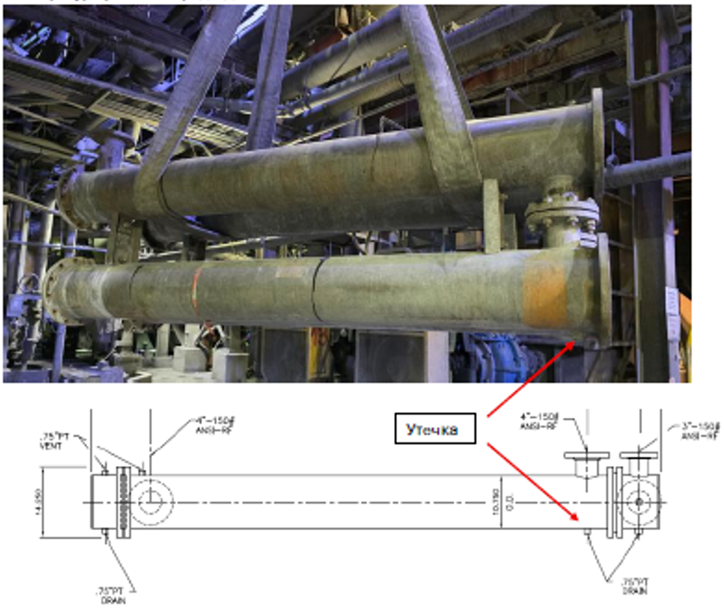

Following the detection of the leak, the heat exchanger was removed from service and replaced.
To determine the technical condition of the removed equipment, a visual inspection and ultrasonic wall thickness measurements of the heat exchanger were conducted. The results of the measurements showed that the actual wall thickness of the heat exchanger ranged from 6.0 mm to 7.5 mm, which is within the allowable limits.
During the visual inspection, the following defects were identified:
- Significant wear of the drain plug;
- Wear of the 3/4" BSPT tapered pipe thread of the drain connection;
- Mechanical damage (fracture) of the edge of the drain nozzle.
The identified defects indicate localized wear of the drain assembly components, which resulted in the leakage of the process solution.
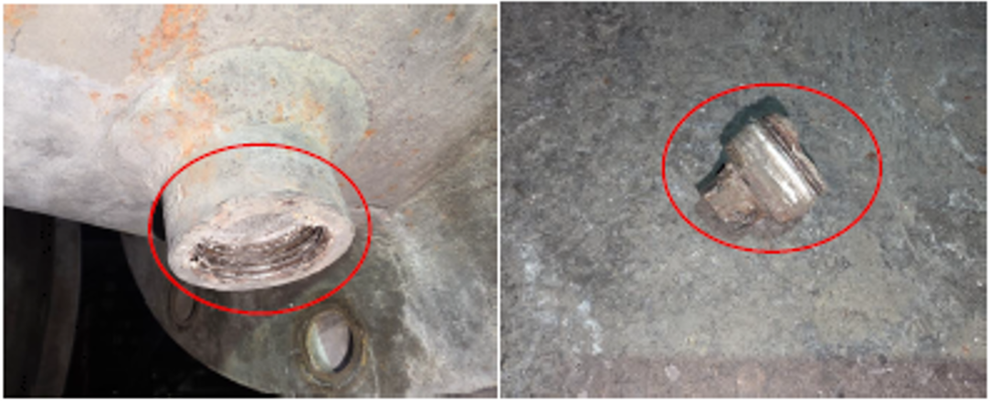
In addition, inspection of the heat exchanger bundle attachment flanges revealed pitting corrosion up to 2 mm deep, indicating localized corrosion-mechanical deterioration of the surfaces.
Wear was also observed on the gasket seating surfaces of the flanges, which may lead to loss of joint integrity. The presence of the above-mentioned defects creates a potential risk of process fluid leakage during continued operation.
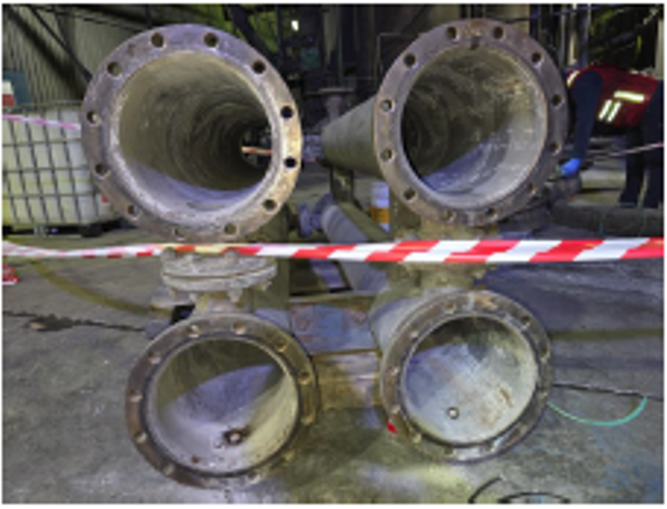

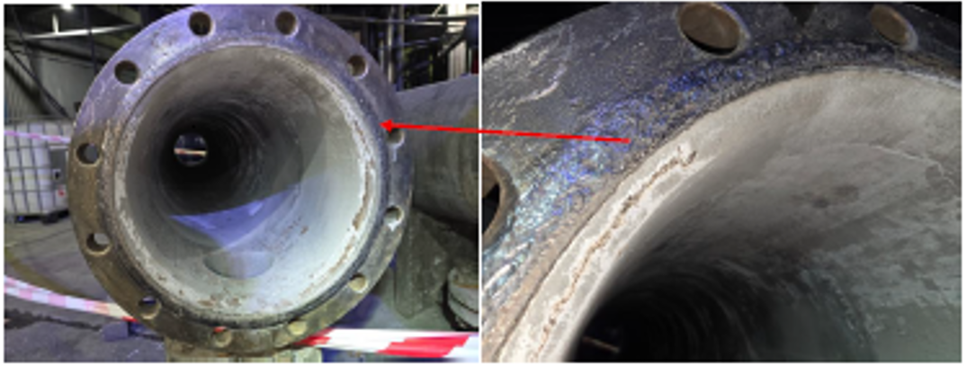
Questions to the Heat Exchanger Manufacturer
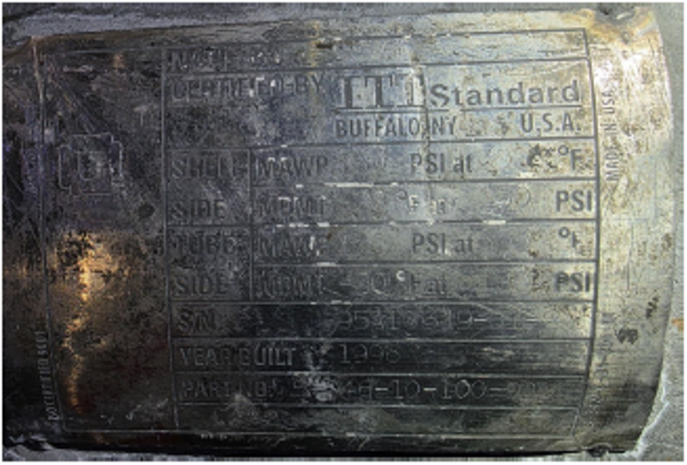
- What is the manufacturer’s recommended service life for heat exchangers of this type when operated in accordance with the specified operating conditions?
- Is further operation of the removed heat exchanger permissible considering the identified defects, provided that repair work is performed?
If yes, under what conditions and limitations?
- Please specify the materials of construction for:
  - the heat exchanger shell;
  - the drain nozzle;
  - the drain plugs.
- Is repair of this heat exchanger feasible?
Please advise on the recommended methods for restoration of the flange sealing surfaces, including acceptable methods of:
  - machining;
  - weld overlay (build-up welding).
  - use of repair compounds or inserts.
- Are drain nozzles and drain plugs available as spare parts for replacement?
If so, please provide the applicable part numbers and lead times.
- Please provide the manufacturer's recommendations for performing welding work on heat exchangers of this type, including:
- permitted welding processes;
- welder qualification requirements;
- limitations on the permissible extent of welding repairs.
7. Please provide the technical specifications and the original operation and maintenance manual for the heat exchangers identified below.
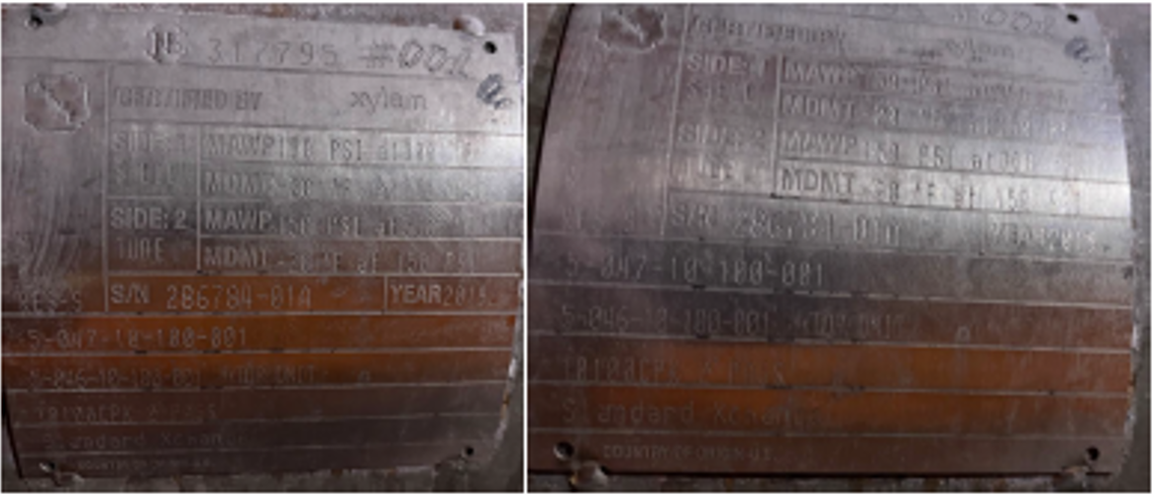
Report prepared by:
Kyialbek Alimbekov
Maintenance Reliability Engineer

