

Terms of Reference for
the purchase of FOGLight rock fall indicators or equivalent for Kumtor Underground Mine, Kumtor Gold Company CJSC

Item  № | List of basic data and requirements | Basic data and requirements
1. | Delivery location | KUMTOR GOLD COMPANY CJSC, 9 Naryn highway, Balykchy, Kyrgyz Republic.
2. | Client | Kumtor Gold Company CJSC, Underground Mining Department.
3. | General provisions | The purpose of these Terms of Reference is the supply of FOGLight indicators or equivalent, designed for early detection of rock mass stratification in underground development backs. The devices provide visual and light alarms in case of excessive displacement, contributing to improved safety of underground mining operations.
4. | Product name and characteristics
  Item | Name | Length, m | Diameter of borehole, mm
  1 | FOGLight Dual Mode or equivalent | 3.0 | 41-43
  2 | FOGLight Dual Mode or equivalent | 4.0 | 41-43
  3 | FOGLight Dual Mode or equivalent | 6.0 | 41-43
 | Scope of application | The indicators are designed to monitor the condition of the backs in underground developments, including drifting and stoping operations at the Kumtor Mine.
 | Technical requirements | - The devices shall be resistant to vibration, dust, and moisture.  - Materials shall be impact-resistant and corrosion-resistant.  - Light indication:  - Green LED – safe condition.  - Red/amber LED – displacement threshold exceeded.  - Mechanical indication:  - Green ring – safe condition.  - Amber ring – activation.  - Battery life:  - Alkaline - at least 6 months.  - Lithium-ion battery - at least 12 months.  - Option to select length and activation threshold according to the Client’s requirements.
 | Packaging, transportation and marking | - The devices shall be supplied with packaging that prevents damage and corrosion.  - Each unit shall be marked with the following information: model, length, displacement threshold, date of manufacture, and manufacturer.  - The devices shall be delivered by the Supplier's transport under DDP terms (9 Naryn Highway, Balykchy).
 | Quality requirements | Each shipment shall be include:  - certificate of conformity.  - quality certificate indicating strength characteristics and geometric parameters.  recommendations for use and maintenance (if required).
 | Laboratory and pilot tests | If requested by the Client, a trial batch may be tested to assess activation accuracy, stability, and operational performance.
10. | Payment and delivery terms | Payment terms: as specified in the Agreement.  The equipment shall be delivered at the Supplier’s expense and responsibility.  Delivery terms: for non-residents of the Kyrgyz Republic – DAP, for residents of the Kyrgyz Republic – DDP.  Delivery deadlines: in accordance with the agreed schedule, subject to production requirements.
11. | Documents to be supplied with each shipment: | - Certificate of Conformity.  - Quality Passport (Quality Certificate).  - Consignment Note (Waybill).  - Certificate of Origin (if required).  - Operation and maintenance instructions (in Russian).  - Instructions for safe handling (if required).
12. | Other terms | All items shall be new and not used.  - The supplied Goods shall be covered by a warranty period of not less than 12 months.  - Preference shall be given to items included in the list of approved manufacturers or having proven positive operational performance in industrial environments.

Appendix.

FOGLight Dual Mode or equivalent:

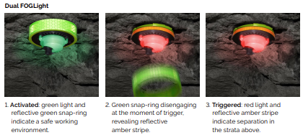
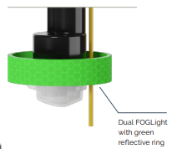
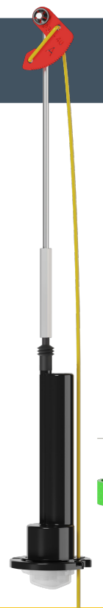

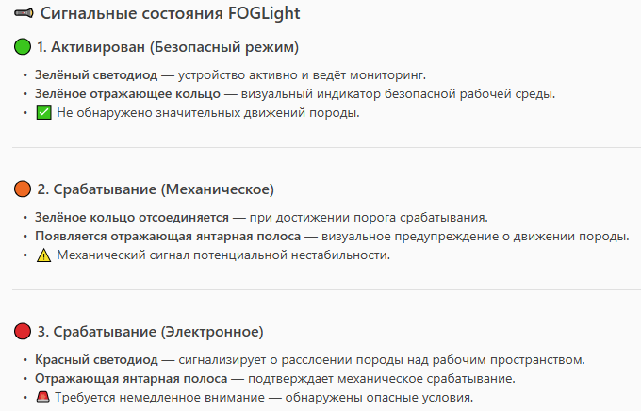
FOGLight Signal States
1. Activated (Safe Mode)
- Green LED – the device is active and performing monitoring.
- Green reflective ring – visual indicator of a safe working environment.
- No significant rock movement detected.
2. Activation (Mechanical)
- Green ring detaches upon reaching the activation threshold.
- Reflective amber stripe appears – visual warning of rock movement.
- Mechanical indication of potential instability.
3. Activation (Electronic)
- Red LED – indicates rock mass delamination above the working area.
- Reflective amber stripe – confirms mechanical activation.
- Immediate attention required – hazardous conditions detected.

