Сток 00.00.765
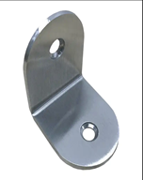
____________________________________________________________
Сток 00.00.767
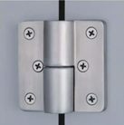
________________________________________________________________
Сток 00.00.769
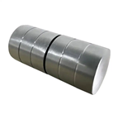
_____________________________________________________________
Сток 00.00.770
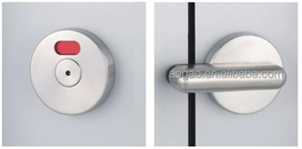
_________________________________________________________________________
Сток 15.01.304
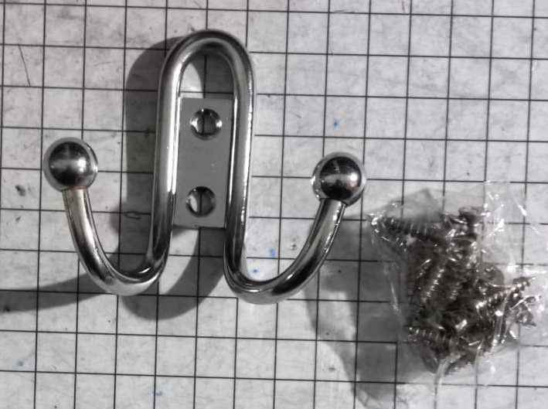
_________________________________________________________________________
Сток 01.01.718
