Appendix #1
Instructions for the preparation of a tender bid (for suppliers)

- The Tender Bid Preparation Instruction (hereinafter referred to as TI) is a Supplier’s manual, which establishes the requirements for the tenderer’s documentation and the conditions for its participation in the tender.
- In the event that the requirements to the participants or the evaluation criteria are not established by the tender documentation, the procuring entity shall not be entitled to apply the unspecified criteria or to require the tenderer to comply with the unspecified requirements or to provide documents not specified in the tender documentation.
- Participants in the tender can be individuals and/or legal entities, in any combination with the official intention of completing a contract.
- It is prohibited to participate in procurement for suppliers, as well as their managers included in the database of unscrupulous suppliers, as well as participating in another supplier as a subcontractor.
- The participant in the competition must not have a conflict of interest. Participants in the competition who are found to have a conflict of interest will be disqualified.
- A contestant may be considered to be in conflict of interest with one or more parties to this contest if any of the following circumstances occur, including, but not limited to:
  - A common legal representative for the purposes of this Bid.
  - A tenderer shall participate in more than one tender in this tender, either individually or as a partner in a joint venture, except for alternative bids permitted in the procurement documentation. This will result in the disqualification of all bids in which he participates.
  - A tenderer who participated as a consulting party in the preparation of the draft or technical specifications of goods, works and services that are the subject of the tender proposal.
  - A tenderer who is related to the employees of the Procuring Organization who:
- - participate directly or indirectly in the preparation of the tender documents or contract specifications and/or in the evaluation of the tender under such contract.
- - participate in the implementation or supervision of such a contract if the conflict arising from such relationship has not been resolved in a manner acceptable to the Procuring Entity throughout the procurement and performance of the contract.
- All procurement participants must comply with the basic principles of ethical conduct in the procurement process and in the execution of procurement contracts. Members must not be involved in misconduct such as corruption, fraud, collusion, coercion, and bribery.
- In the event of intra-group cooperation of people participating in the procurement, the participants in the procurement procedure shall comply with the requirements of the legislation of the Kyrgyz Republic on interested transactions.
- If the procuring entity discovers the facts referred to in this paragraph, the proposals of such suppliers shall be rejected.
Tender application
- The tender prepared by the Tenderer (hereinafter referred to as the “Tender Bid,” as well as the “Proposal”), as well as all correspondence and documents relating to this Tender exchanged between the Tenderer and the Procuring Entity, shall be drawn up in the language specified in the Invitation.
- If the proposal is accompanied by documents in other languages (copies of certificates, technical documentation, promotional materials, etc.), such documents must be translated into the language of the procurement documentation, and the translator’s signature must be notarized.
- The Participant shall bear all costs associated with the preparation and submission of the Bid. The procuring entity shall not be liable for the recovery of such costs, regardless of the outcome of the competition.
- Documentation included in the supplier’s tender bid under the one-stage single-package procedure:
  - a tender application/proposal of the supplier signed by the supplier’s authorized person, including with the use of an electronic signature.
  - completed forms for the supply of goods, scope of work and services in accordance with the Appendices of this Standard Tender Documentation.
  - technical specifications of the proposed goods, consumables, spare parts, etc.;
  - table of prices for the supply of goods.
  - a statement of the scope of work/provision of services (for each type/name) indicating the cost including applicable taxes.
  - schedule of delivery of goods/performance of work/provision of services.
  - methodology for performing work/providing services (if required),
  - licenses/permits, in accordance with the current legislation of the Kyrgyz Republic on the licensing and permitting system (if applicable), patents, etc.
  - information on qualifications, with supporting documents on compliance with the established qualification requirements (letters of authorization, certificates, financial statements, copies of contracts confirming experience and acts of acceptance of goods, works and services).
  - guarantee security for the supplier’s tender bid.
  - registration documents of the supplier: extract from the state register of legal entities, certificate of an individual entrepreneur, copy of the Charter/Regulations of the participant, documents confirming the authority of the person who signed the Tender Bid.
- Documentation included in the supplier’s tender bid under a one-stage two-package procedure.
- The tender proposal shall consist of two packages of documents submitted simultaneously, one of which shall contain the Technical Proposal, and the other - the Price Proposal, and both packages of documents shall be included in the tender bid.
- The supplier’s technical proposal must consist of the following documents:
  - Supplier’s technical proposal signed by the supplier's authorized person, including the use of an electronic signature.
  - guarantee security for the supplier’s tender bid.
  - technical specifications of the proposed goods, consumables, spare parts, etc.
  - schedule of delivery of goods/performance of work/provision of services.
  - methodology for performing work/providing services (if required).
  - licenses/permits, in accordance with the current legislation of the Kyrgyz Republic on the licensing and permitting system (if applicable), patents, etc.
  - Information on qualifications, with supporting documents on compliance with the established qualification requirements (letters of authorization, certificates, financial statements, copies of contracts confirming experience and acts of acceptance of goods, work, and services).
  - Registration documents of the supplier: extract from the state register of legal entities, certificate of an individual entrepreneur, a copy of the Charter/Regulations of the participant, documents confirming the authority of the person who signed the Tender Bid.
  - Other documents are required by the procurement documentation.
- The supplier’s price proposal must consist of the following documents:
  - Supplier’s price proposal signed by the supplier’s authorized person, including the use of an electronic signature.
  - table of prices for the supply of goods.
  - a statement of the scope of work/provision of services (for each type/name) indicating the cost including applicable taxes.
  - other documents required by the procurement documentation.
- The tender application is submitted in electronic form, by uploading the completed forms and related documents in scanned form to the System.
- Each supplier can submit only one proposal for participation in the procurement - either independently or as part of a simple partnership. If a supplier has submitted more than one proposal - either alone or as part of a simple partnership - all proposals of this supplier will be rejected.
- A tenderer may amend, replace, or withdraw its Tender Bid after its submission in the System before the expiry of the deadline for submission of tenders set forth in the Invitation of the Procuring Entity.
- The Supplier may request clarification on the provisions of the procurement documentation through the System no later than 3 (three) business days prior to the expiry of the deadline for submission of bids through the System. The procuring entity shall, no later than two (2) working days, respond to such request through the System.
- In case of amendments to the procurement documentation, the deadline for submission of bids shall be extended for a period of at least 5 (five) business days. At the same time, the System automatically sends notifications to all participants about the extension of the deadlines.
- The procuring entity is permitted to clarify aspects of the description of the subject matter of the procurement by:
- - Deletion or modification of any aspect of the originally specified technical, quality, or performance characteristics of the subject of procurement and the addition of new characteristics that meet the requirements of the Model Policy.
- - Deletion or modification of any of the original criteria for the consideration or evaluation of a proposal, or the inclusion of new criteria that meet the requirements of the Model Policy, if those criteria relate to a change in the technical, quality or performance characteristics of the subject matter of the procurement.
- - communicate any deletion, modification, or inclusion to submit final proposals.
Validity period of the Supplier’s proposal
- Validity period of the supplier’s offer:
  - The supplier’s bid shall be valid for the period specified in the tender documentation. The validity period of the supplier’s bid shall commence on the date set by the Customer as the deadline for submission of bids. A supplier’s offer valid for a shorter period will be rejected by the Customer as not meeting the requirements.
  - the supplier’s proposal shall be valid and may not be amended or withdrawn within the period specified by the supplier, in exceptional cases, if the evaluation and signing of the contract cannot be completed within the period of validity of the Proposal, the procuring entity may request the supplier to extend the validity of the proposal for a specified period through the System;
  - it is not allowed to extend the period after the expiration of the validity period of the Supplier’s proposals. The Supplier shall have the right to refuse a request to extend the validity of its Offer without losing the right to return the Supplier’s Bid Guarantee Bond.
  - If, in accordance with the procurement documentation, a security for the tender bid by a bank guarantee is requested, it shall also be extended for 14 days after the expiry of the extended validity period of the supplier’s tender. The supplier who has satisfied the request shall not be obliged and shall not have the right to change its tender offer.
  - Suppliers have the right not to extend the validity period of offers, in which case their offer is subject to rejection.

Price and currency of the tender bid
- The prices quoted by the supplier must include all costs, taxes, duties, and fees paid by the supplier in connection with the supply of goods, the performance of work or the provision of services.
- The prices quoted by the supplier shall remain fixed for the duration of the performance of the contract and shall not change under any circumstances, except in the event of a change in tax legislation. A proposal that allows for price changes will be considered as not meeting the basic conditions of the procurement documentation and shall be rejected.
- Prices must be indicated in the currency provided for in the procurement documentation. In cases where a foreign currency is established, then payment under the contract shall be made in the national currency in the amount equivalent to the foreign currency, at the official exchange rate of the relevant currency established by the National Bank of the Kyrgyz Republic on the day of payment, or at a fixed rate in the contract.
Tender bid bond guarantee
- Tender bid bond guarantee (hereinafter referred to as the TBBG) shall be applied if such a requirement is established by the procuring organization. In this case, the bond guarantee of the supplier’s tender bid may be carried out:
- - in cash in an amount not exceeding 2 per cent of the planned value of the subject of procurement, which shall be paid into the settlement account of the procuring entity.
- - in the form of a bank guarantee.
- - in the form of a declaration guaranteeing the Supplier’s proposal.
- In case of payment of TBBG in cash, the supplier is obliged to pay and attach documentary evidence of payment for TBBG, and in case of submission of a Bid not for all lots, payment is made in proportion to the lots for which the Bid is submitted.
- In addition, the supplier shall ensure the receipt of funds to the settlement account of the procuring entity, indicating the purchase number until the bids are opened.
- The TBBG must be valid for 14 days after the initial term of the supplier’s offer, or after any renewal period if requested.
- Payment for TBBG by participants in a simple partnership is carried out by any of the partners. In the case of a simple partnership (consortium), if the bond guarantee is submitted in the form of a bank guarantee, the bank guarantee must be issued in the name of the simple partnership (consortium).
- The supplier’s TBBG is withheld in the following cases:
- - refusal to sign a contract on the terms of the procurement documentation and provided for in the supplier’s proposal, except for cases where such refusal is related to the introduction of a state of emergency, a state of emergency or force majeure, provided that the procurement announcement is published before the introduction of such a regime or before the occurrence of such circumstances;
- - withdrawing the supplier’s proposal after its opening and before its expiration.
- - Failure to accept the correction of arithmetic errors.
- - refusal to provide a bond guarantee for the performance of the contract, if such a requirement is established by the procurement documentation.
- The above grounds for withholding TBBG must be reflected in the bank guarantee.
- TBBG shall be returned to the Tender Participants in the same amount and currency in which it was provided, after signing a contract with the winner of the tender and providing a bond guarantee for the performance of the contract (if required) or after the expiration of the TBBG, whichever occurs first.
Consortium
- A supplier’s proposal submitted by a simple partnership consisting of two or more people (consortium) must meet the following requirements:
  - The lead partner shall meet at least 40 per cent of the qualification requirements set out in the procurement documentation, and the remaining partners shall be at the discretion of the procuring entity.
  - The experience of the members of the simple partnership, the financial and technical capabilities of each of the partners of the simple partnership shall be summed up and must comply with 100 percent of the established requirements in the procurement documentation. In case of non-compliance with these requirements, the proposal of the supplier of a simple partnership is rejected.
  - It must include an agreement concluded between the partners in accordance with the Civil Code of the Kyrgyz Republic.
  - one of the partners must be the leader, authorized to bear obligations and receive instructions on behalf of and on behalf of any partner and all partners, which is confirmed by the relevant simple partnership agreement.
  - A proposal from a simple partnership (consortium) is submitted and must be signed by the leading partner, if there is a power of attorney for signing from the other members of the simple partnership (consortium), or must be signed by all members of the simple partnership (consortium).
  - The proposal is submitted in the system from the personal account of the leading partner, determined by the agreement of a simple partnership.
Qualification Requirements
- Suppliers must provide information confirming compliance with the qualification requirements established by the purchasing organization in the procurement documentation and attach (if required) relevant supporting evidence/documents (copies), such as:
  - Acceptance certificates for delivered goods, completed works/services under relevant contracts in amounts proportional to the value of the lots participated in (in case of bidding for several lots, copies of such certificates shall be provided proportionally to the total value of all lots) to confirm similar experience in performing contracts related to the procurement subject for the amount of the lot or procurement (if conducted as a single lot), indicating the period, in accordance with the procurement documentation;
  - Cash flow statements, profit and loss statements, balance sheets or a unified tax declaration, or a bank statement (original), confirming the supplier’s financial solvency.
  - Licenses/permits (if the activity is subject to licensing; for participants who are not residents of the Kyrgyz Republic — a license from the country of origin is required, in case of mutual recognition of licenses by the parties under an international agreement to which the Kyrgyz Republic is a party), with appendices;
  - Lease/use agreements, technical passports for vehicles, equipment invoices confirming the availability of material and technical resources necessary for contract performance.
  - employment record books, contracts, permits, certificates, diplomas, certificates, certificates, certificates, certificates, certificates, certificates, and other documents that confirm the qualifications of employees with the necessary knowledge and experience.
- Specific qualification and other requirements for each procurement are entered by the Customer directly in the System.
Technical Specification
- The goods supplied must be new, not previously used, manufactured according to the latest or currently in production modifications, be current and include all the latest improvements in construction and materials, reflect all recent achievements in the field of design and development of materials, unless otherwise provided by the competition.
- Precise and clear specifications are a prerequisite for the bidders to be able to respond realistically and competitively to the Customer’s requirements without reservations or conditions.
- In the context of competitive procedures, specifications should be drafted in such a way as to ensure the widest possible competition, while at the same time clearly reflecting the required standards of materials, equipment, other supplies, and quality of work to be provided. Only then will the objectives of economy, efficiency and equality in procurement be achieved, the compliance of bids with the requirements will be ensured and the subsequent task of evaluating bids will be facilitated.
- The quality and safety of the goods supplied, and the consumables used in the performance of work and services, must comply with the relevant technical regulations and be confirmed by certificates of conformity.
- Goods or materials used in work or services must meet the standards specified in the technical requirements and comply with the technical regulations of the Kyrgyz Republic, or international norms and standards that provide an equivalent or higher level of quality.
- If the subject of the purchase is included in the List of Goods Subject to Mandatory Certification, it is necessary to provide the relevant confirmation of certification.
- Design documents, drawings, calculations, reports, technical engineering documents, photographic materials, surveys, diagrams, and other similar documents must be clear and readable.
- Drawings (if necessary) are usually bound in a separate volume, which is often larger than other volumes of the contract. The size is determined by the scale of the drawings, which must not be reduced to such an extent that the parts become illegible.
- Construction drawings, even if they are not fully developed, should contain sufficient detail to enable the procuring entity to understand the type and complexity of the work and to determine the price from the quantity bill or schedule.
- The supplier has the right to offer alternative technical solutions for certain parts of the work. Alternative solutions are appropriate in cases where obvious (and potentially less expensive) alternative solutions are possible in comparison with the technical solutions specified in the tender documentation for certain elements of work, considering the comparative specialized advantages of potential Bidders.
- Such alternative solutions by the supplier should be accompanied by all the information necessary for a full assessment by the procuring entity, including drawings, design calculations, technical specifications, price breakdowns, proposed construction methodology and other relevant details.
Declaration of Good Faith and Anti-Corruption Clause
Bidders must adhere to high standards of ethics during procurement and contract execution procedures, and they must not be involved in misconduct such as collusion, bribery, fraud, and corruption.

Appendix #2

SUPPLIER APPLICATION/PROPOSAL
To: Kumtor Gold Company CJSC
From: _____________________________________________________________
Having studied the published procurement documentation, we offer to provide services - _________________________________________
(name of the purchase)

in accordance with all the terms and requirements of the procurement documentation, confirmed by the completed forms, which is part of this supplier’s proposal.
We hereby confirm our legal capacity to participate in this procurement.
Our bid will be valid for __________ (specify expiry date) days from the date set for the deadline for submission of bids and will remain binding on us and may be accepted at any time before the expiry of this deadline.
In case our proposal is determined as the winner, we undertake:
1) provide all the necessary documents included in the supplier’s offer.
2) provide services in accordance with the requirements specified in the procurement documentation.

Name of the supplier
_______________________________________________________
(full name, position) (Signed)
Stamp

Appendix #3

DECLARATION OF GOOD FAITH AND ANTI-CORRUPTION CLAUSE

To:
Procurement title: ___________-
I hereby reaffirm my commitment to comply with high standards of economic conduct and ethical principles, to prevent corrupt practices, to ensure honesty and transparency in business relations, and therefore I undertake to:
act in accordance with the principles of honesty, reliability, and professionalism in all aspects of its relationship with the procuring entity.
- provide high quality products, works or services that meet the established standards and requirements of the procuring entity.
- comply with all applicable laws, rules, and regulations in carrying out its activities and fulfilling its obligations under the contract.
- provide all the necessary information about products, services, prices, terms of delivery and other important aspects of the purchase.
- not to commit corrupt acts, such as bribery, bribery, fraud, and other actions contrary to the law and ethical standards.
- refrain from committing any unacceptable or illegal actions that may harm the other party, third parties or society as a whole.
- prevent a conflict of interest and take measures to prevent possible situations that may create the impression of bias or illegality of the actions of the party.
- it is unacceptable to stimulate employees of the procuring entity in any way, including the payment of any money and/or the transfer of other material values, directly or indirectly, to influence the actions or decisions of these people in order to obtain any advantages or achieve other goals.
- not to carry out actions that can be qualified as extortion of a bribe/illegal remuneration or the subject of commercial bribery, mediation in commercial bribery/bribery, giving/receiving a bribe, commercial bribery, illegal remuneration, abuse of power, as well as other actions that violate the requirements of the legislation of the Kyrgyz Republic in the field of combating corruption;

Supplier

Full name, position _____________________/Stamp

Appendix #4
DECLARATION guaranteeing the tender bid

To: ______________________________________________________
Procurement title ____________________________________________
Procurement number _________________________________________

We understand that according to your terms, bids must be supported by a Declaration guaranteeing a bid/proposal. We agree that we will be automatically excluded from participation in procurement under any contract for a period of 2 years, starting from the date of receipt of the notification from KGC, if we are in breach of our obligations under the terms of the procurement documentation because we:
1) have withdrawn their proposal within the period of its validity specified by the Supplier in the proposal; or
2) have not accepted the correction of arithmetic errors in accordance with the Instructions for Suppliers; or
(3) Having been notified by the procuring entity of the award of the contract: - failed or refused to sign the contract.
- failed or refused to provide a guarantee bond for the performance of the contract, in accordance with the procurement documentation.
It is hereby confirmed that in case of non-fulfillment of any of these obligations, KGC has the right to initiate the inclusion of us in the “Database of Unscrupulous Suppliers” or “Register of Mala Fide Vendors.”
This declaration will expire if we are not a winning participant after we have received your notification of the name of the winning participant or 28 days after the expiry of our proposal.

Supplier ______________________________________________/ (signature) (full name, position) stamp

Appendix #5
QUALIFICATION INFORMATION
Supplier Name: _________________________________________________
In the event that the Supplier submits a Proposal on behalf of a simple partnership (consortium), the information specified in clause 1 below shall be provided for each partner of the simple partnership (consortium).
Supplier’s Legar Address: ___________________________________________________
Supplier’s Registration Date: _____________________________________________________
(attach copies of the Charter and an extract from the register of legal entities).

Main activity: _________________________________________________
License/Permit Data: _______________________________________________
(attach copies of licenses if the activity is licensed)
- The total volume of similar/similar contracts performed during the __________________________
(specify the period required by the procurement documentation) in the amount of KGS ____________________, with the provision of copies of acts of acceptance and transfer of goods, work performed or services rendered.

# | Item | Terms of contract performance | Customer party under the contract (name, address, contact phone numbers) | Contract value, thousand soms | Results details, feedback (if any)

2. Information on current and unfinished works/services for _________ (indicate the period requested by KGC in the procurement documentation, the presence of unfinished facilities with a volume of less than 70 percent).
(if available, the above form is used according to paragraph 1 of this Appendix, if not, indicate NO).
3. Qualification and experience of employees, specialists (including in the case of purchase of equipment, mechanisms with installation and installation) for the performance of the contract, required in the procurement documentation. Indicate labor resources (with the provision of copies of passports, diplomas, certificates, employment record books, contracts, etc.):
# | Name | Position or profession | Education | Specialization and work experience in the specialty | Availability of diplomas and certificates

4. Information on the availability of material and technical base, according to the procurement documentation, for the performance of work/provision of services. It is necessary to attach supporting documents (technical passports, lease agreement, etc.).
# | Type of property (equipment, land, real estate, vehicle, etc.) | Quantity, volume, size/ unit | Location | Right of ownership or other right of use (details of the document) | Year of manufacture and other characteristics parameters
5. Information on the supplier’s financial activities for _________ (indicate the period required by the procurement documentation.
6. Presence or absence of arrears in the payment of taxes and mandatory payments to the Social Fund of the Kyrgyz Republic (if applicable).

Supplier________________ (signature) /_______________________ / (full name, position)

Appendix #6

SERVICE AGREEMENT #KGC-P/V-

Bishkek “____” _____________ 2026

Kumtor Gold Company CJSC, hereinafter referred to as the “Customer,” represented by the full name, position acting based on ____, on the one hand, and
_______ in the full name, position acting based on _______, on the other hand, collectively referred to as the “Parties,” each separately a “Party,” have entered into a service agreement (hereinafter referred to as the “Agreement”), as follows:

- The Agreement consists of the following parts, each of which is an integral part of the Agreement:
a) this main contract (hereinafter referred to as the “Main Agreement”).
b) the general terms and conditions of the Agreement posted on the Customer’s website and available for review by the Parties at the links: General Terms and https://www.kumtor.kg/wp-content/uploads/2020/11/general-terms_service_2020_nov.pdf (hereinafter referred to as the “General Terms”); to the extent that they do not contradict the Agreement.
c) Terms of Reference.
d) all acts of services rendered signed by both Parties.

- In accordance with the terms of the Agreement, the Contractor undertakes to provide the following services: ________________ (collectively referred to as the “Services”), and the Customer undertakes to accept and pay for the Services in the manner and on the terms provided for in the Agreement.

- The cost of the Services under the Agreement is ______________, which includes all applicable taxes and fees, as well as all expenses of the Contractor related to the provision of services. The cost of services is fixed and is not subject to change, unless otherwise established by a written agreement of the Parties.

- The Customer shall pay the Contractor the Cost of the Services within 10 (ten) banking days after the Parties sign the relevant act of services rendered in the manner provided for in the General Conditions.

- The Contractor undertakes to comply with the safety requirements and the rules of presence at the Customer's facilities. The Customer does not bear any responsibility for violation of safety rules by the Contractor when providing services.

- Place of provision of Services/ Allocated area for the provision of services:
“Allocated Service Area” is a site on the Customer’s territory where the Contractor provides Services under the Agreement (or is in connection with the provision of Services under the Agreement). Contractor shall be solely responsible for (i) the safe conduct of work, safe operation of equipment in the Designated Work Area, at the Kumtor mine and at any other site of the Client; (ii) for any accidents and breakdowns, environmental pollution in the Designated Area and outside it, on the territory of the Kumtor mine and on any other territory of the Customer, caused by the fault of the Contractor.
- Provision of equipment, materials, and tools:
The services are provided by the Customer’s materials, equipment, machinery, tools, and other property, for the safety of which the Contractor is responsible.
- Provision of personal protective equipment (PPE) to the Contractor at the Kumtor mine:
all PPE required for the performance of work is provided (negotiated additionally when signing the contract) for the period of the provision of the Services.

- Provision of accommodation and meals to the Contractor at the Kumtor mine: (to be negotiated additionally when signing the contract).

- The terms of services provided by the Contractor set by the Customer at the Kumtor mine: up to *** (to be negotiated additionally when signing the contract).

- Transportation to the Place of Service and back: (to be negotiated additionally when signing the contract).

- The dates of ascent/descent to/from the Kumtor mine or other territory of the Customer must be agreed with the Customer in advance in writing. The day of ascent and the day of descent to/from the Kumtor mine(s) are equated in general to one day of services rendered.

- Medical Admission to Work: The Contractor undertakes to carry a medical certificate authorizing him to work, provide the Services and be at an altitude of 4000 m above sea level. Copies of such medical certificates, including test results, cardiograms, etc., must be handed over by the Contractor to the Customer prior to his arrival at the Kumtor Mine, otherwise the Contractor will not be allowed to work at the Kumtor Mine.

- Occupational health and safety in the provision of Services: The Contractor undertakes to undergo an introductory briefing on the Customer’s program on health, safety, and environment, first aid training, as well as to familiarize himself with the rules of being on the territory of the Customer. Introductory briefing on labor protection, safety and environment is carried out by the Customer on its territory at its own expense and on its own. confirming that the Contractor has completed the above training prior to the commencement of the provision of the Services.

- Rules for being on the Customer’s territory: The Contractor undertakes to ensure compliance with the Customer’s requirements that the storage of alcoholic beverages, drugs, narcotic drugs and weapons, as well as their consumption and use, is prohibited in the Designated Work Area, as well as throughout the Kumtor mine and other territory of the Customer. The Contractor undertakes to comply with the requirements of the legislation of the Kyrgyz Republic and the Customer’s requirements in terms of labor protection and safety and comply with the accepted standards of conduct. Based on a written notice sent by the Customer to the Contractor, the latter will be immediately suspended from the provision of Services at any of the Customer’s facilities and the Agreement may be terminated. The Contractor undertakes to maintain cleanliness and order at the Customer’s facilities and take all precautions to prevent environmental pollution, while the Contractor undertakes to ensure the collection of garbage generated during the provision of the Services in the place determined by the Customer.
Other conditions: not applicable.

- Responsible people (as defined in the General Terms):
The people responsible on the part of the Customer are:

The head(s) of the department that engages the Contractor.

- Special terms of the Agreement: notwithstanding the provisions of the Agreement, the Parties have agreed to the following specific conditions: not applicable.
In the event of a discrepancy between other terms of the Agreement and the special terms set forth in this clause, the provisions of the special terms shall prevail.

- First aid training by the Contractor: the Contractor undertakes to undergo first aid training. This training is carried out by the Contractor independently and at its own expense, while the Customer has the right to give its recommendations regarding the most acceptable and qualified organizations, the services of which the Contractor should use to conduct first aid training.
- Notwithstanding the provisions of the General Terms and Conditions, the Parties have agreed that all disputes and disagreements arising between the Parties shall be settled through negotiations between the Parties in good faith. The preliminary (pre-trial) procedure for resolving any dispute between the Parties is mandatory.
- If the Parties have not reached an agreement in the course of negotiations, all disputes and disagreements arising between the Parties under the Agreement or arising from it, and relating to its conclusion, amendment or invalidation, shall be resolved in the courts of the Kyrgyz Republic at the location (legal address) of the Customer (contractual jurisdiction) in accordance with the legislation of the Kyrgyz Republic. Unless otherwise expressly provided for by the Agreement, the existence of any dispute, including the consideration of such a dispute in court, does not give the Contractor the right to suspend the performance of its obligations under the Agreement.

- Neither Party may transfer its rights and obligations under this Agreement to a third party without the written consent of the other Party.

- Any intellectual property rights related to the intellectual property products owned by the Customer during the execution of this Agreement and further products/designs/ideas/method, databases, archives, and other similar results related to the Services belong exclusively to the Customer in accordance with international and Kyrgyz laws on intellectual property. The Customer has the right to individually use and dispose of such products/design/method, etc., to his own discretion in accordance with their purpose. The Contractor agrees that he has no right to use or create situations as a result of which other persons can use such products/design/ideas/method, etc., without the prior consent of the Customer.

- Each Party hereby acknowledges receipt of its copy of the Agreement and that it has read the contents of the Agreement in its entirety, including the General Conditions, and agrees to and accepts all the terms and conditions contained therein. The General Terms and Conditions of the Agreement are drawn up in English and Russian; both texts have equal legal force, and in case of discrepancies between the English and Russian texts of the General Terms, the Russian text shall prevail.

- The Agreement enters into force from the moment it is signed by both Parties and is valid until ________________, and in terms of mutual settlements – until the Parties fully fulfill their obligations.

- Addresses, bank details, signatures of the Parties:
Client: | Executor:
Kumtor Gold Company CJSC
Address: Kyrgyz Republic
Bishkek, Ibraimov Street, 24
Tax Identification Number: 01602199310079
Bank details:
Bank: OJSC “Aiyl Bank|”
BIC: 135001
Settlement account #1350100020023658
Code and name of the State Tax Inspectorate: 999 – UGNS KKN
Tel: (+996 312) 90-07-07, 90-08-08
  Client
  Name
  Position
  Executor

APPENDIX #7 TO THE INVITATION
Quotation

A financial/commercial proposal must be provided in a separate letter in a password-protected archive. The password is provided at the request of the person responsible for this competition.
Name of the supplier_________________________
Subject of procurement_______________________
Procurement number_________________________

Bill of Quantities / List of Services

# | # Name  works / services | Measure  Unit | Quantity | Price per unit (currency) excluding taxes | Total price (currency) excluding taxes | VAT and other taxes  (currency) | Overall total Price (Currency) Including All Applicable Taxes
1 | 2 | 3 | 4 | 5 | 6=4*5 | 7 | 8=6+7

Note: The supplier indicates prices for all types of work/services included in the Bill of Quantities or List of Services. Types of works/services for which prices are not indicated are not subject to payment after their completion. If the supplier has not estimated and indicated prices, he must indicate in which types of work they are included. All duties, taxes, and other charges that the supplier is obliged to pay on the basis of the current legislation of the Kyrgyz Republic must be included in the price of the proposal.
Deadline/Schedule for the performance of work or provision of services
Stages of work / services | Name of types of work / services | Deadlines for the completion of work/services | Stages of work / services
Step 1 | 2 | 3 | Step 1
Step 2 |  |  | Step 2

If necessary, indicate the methods, ways, etc., of performing work or providing services.
Supplier ________________/____________________ /
(signature) (full name, position)
Note: This appendix must be completed by the participant/provider. This form
is included in the tender documentation when purchasing works or services.
Appendix #8

Terms of reference for repair work of the flotation tailings thickener
Item # | Requirements parameters for the goods, works, services to be purchased (subject of procurement) | Specific requirements for goods, work, services
1 | Name/type, quantity/volumes, unit of measurement | Repair of flotation tailings thickener  Scope of work:  - Replacement of the upper drain discharge launder bottom:  - Pre-fabrication of bottom sections according to the Customer’s drawings prior to mobilization at site.  - Delivery of finished sections to the site by the start date of repair works.  - Repair of thickener upper discharge walls (based on inspection results):  - Installation of patches made of 5 mm sheet steel on the upper launder walls, if required.  - Repair of the thickener tank walls (based on inspection results):  - Installation of patches made of 5 mm sheet steel on the tank walls and bottom, if required.  - Replacement of the main bottom shaft.  - Replacement of short, long internal, and external rakes.  - Replacement of well brackets.  - Replacement of the upper well and ring.  - Replacement of the E-duct system.  - Replacement of the feed pipe and nozzle.  - Replacement of the cone scraper.  - Surface preparation (mechanical/sandblasting), and application of polyurethane coating on the walls and bottom of the thickener and the upper launder after completion of installation.  Thickener Technical Data:  - Tank diameter: Ø25.9m  - Tank height: 2.75m  - Rake diameter: Ø25 m.  - Rotation speed: 0.10 rpm  - Medium: aggressive, pulp with a density of 45–50.  The flotation tailings thickener is an open-top tank with a conical bottom used in the Mill to thicken slurry to a specified level.  The thickener is equipped with an agitator with a drive unit and a lifting mechanism.
2 | Place of work | - Kyrgyz Republic, Issyk-Kul region, Kumtor mine.  - Altitude: +4100 m.
3 | Terms (periods) for goods delivery, provision of services, performance of work | - The work execution periods shall be specified in the Commercial Proposal. The Customer shall select proposals with optimal pricing and timelines for the repair work that meet the requirements of the standards and the Terms of Reference.  - The work is planned for the warm period of 2026. The exact execution periods shall be determined at the time of contract conclusion.
4 | Order (sequence, stages) of work performance | - Submission of the Commercial Proposal.  - Fabrication of the upper launder bottom sections and delivery to the Customer’s site.  - Emptying and flushing the thickener tank.  - Surface preparation (mechanical/sandblasting). Materials and equipment are provided by the Customer.  - Joint inspection with participation of the Contractor and the Mill Planning & Engineering Department (photo and video recording).  - Agreement on the final scope of repair, materials, and coating based on the inspection results.  - The Customer ensures timely delivery of the required materials, spare parts, instruments, fasteners, and coatings to the work site. Materials are provided by the Customer.  - Dismantling/installation according to the agreed scope.  - Alignment of the shaft and rakes jointly with the Mill Planning & Engineering Department.  - Interim inspection of concealed works and NDT reporting by the Mill Planning & Engineering Department.  - Application of polyurethane coating. Materials and equipment are provided by the Customer.  - Cleaning, restoration of technological readiness.  - Handover and acceptance (completion certificates, as-built documentation).
5 | Requirements for goods supplied, work performed, services rendered | - The Contractor shall provide certified welders and fitters with experience in cutting and welding operations in tanks, as well as specialists in the assembly of process equipment.  - The Contractor shall perform the work using its own tools, installation equipment, PPE, and measuring instruments (the Customer provides only equipment required for sandblasting and application of polyurethane coating).  - The works shall be performed in strict accordance with this Technical Specification, drawings (Appendix 1), and the construction codes and regulations in force in the Kyrgyz Republic.  - Accommodation and meals for the Contractor’s personnel at the Kumtor mine shall be provided by the Customer.  - Transportation of the Contractor’s personnel to and from the worksite shall be provided by the Customer.  Safety requirements:  - Fencing of hazardous areas.  - Warning signs.  - Use of PPE.  - Work in a confined space is strictly according to the work permit.  - Hot work is strictly according to the work permit.  - Prohibition of unauthorized persons in the repair area.
6 | Procedure for Delivery and Acceptance of Goods, Services, Work Results | Acceptance is carried out by the Customer’s commission based on the results of:  - Visual inspection.  - Measurements and verification of joint quality.  - Coating thickness and adhesion control.  - Geometry control (alignment of the shaft and rakes).  The work shall be considered accepted upon signing of the completion certificate.
7 | Requirements for the transfer of technical and other documents to the Customer upon completion and delivery of work | The Contractor shall submit to the Customer:  - The completion certificate.  - Inspection report “before repair” and “after repair.”
8 | Warranty obligations | - The Contractor shall provide a warranty for the quality of welding and the completed works.  - In case of defects detected, their elimination shall be carried out at the Contractor’s expense.  - Warranty period: not less than 12 months from the date of commissioning.

Appendix 1.
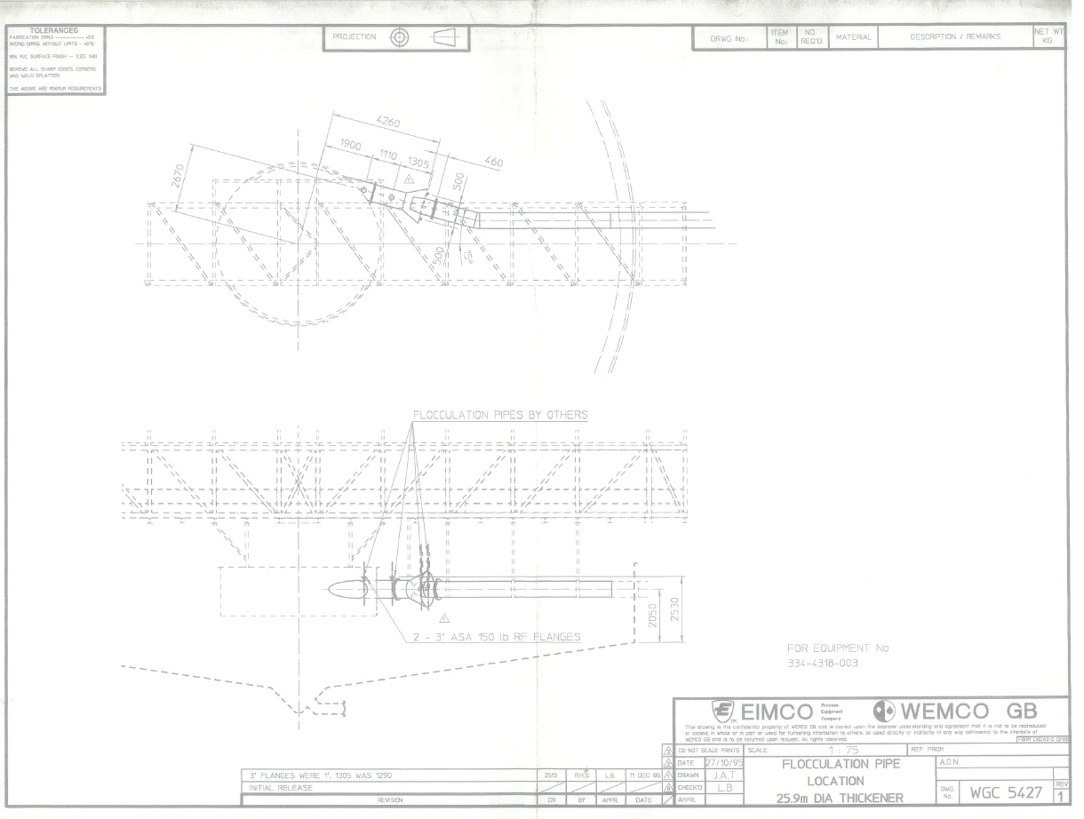
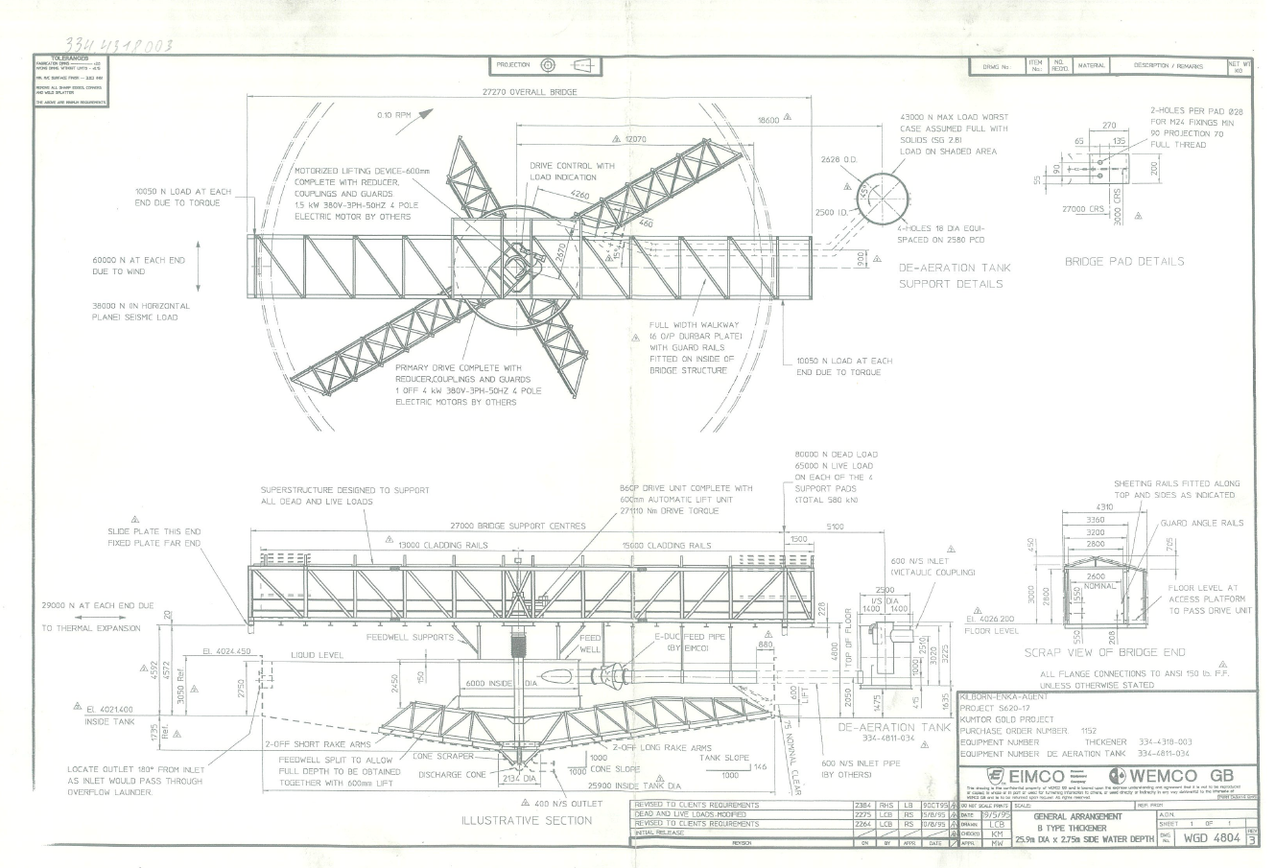

Appendix 2
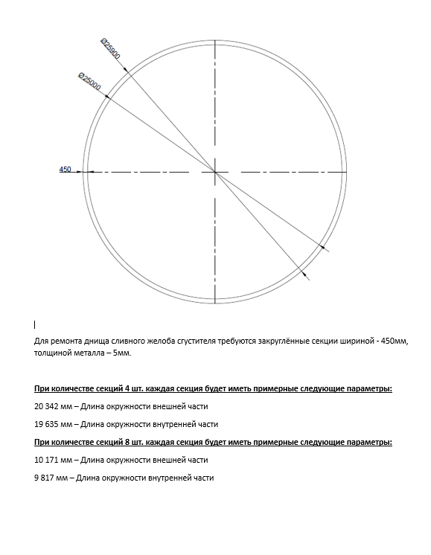
Appendix 2
For the repair of the thickener discharge launder bottom, curved sections with a width of 450 mm and a metal thickness of 5 mm are required.
For 4 sections, each section will have the following approximate parameters:
20,342 mm – External circumference length
19,635 mm – Internal circumference length

For 8 sections, each section will have the following approximate parameters:
10,171 mm – External circumference length
9,817 mm – Internal circumference length

