TERMS OF REFERENCE No2 (updated)

to perform wells installations reverse drilling (RC-drilling) at the Kumtor concession area in 2019.

The basis for performing operations: The existence of the Revised Concession Agreement dated as of June 6, 2009 between the Government of the Kyrgyz Republic and Kumtor Gold Company.

Special purpose:
- Exploration and geological exploration works in the Sarytor-Boordu and Northeastern areas.

Spatial location of the object:
- The Kumtor Mine Site is located in the Jety-Oguz district of the Issyk-Kul region. The north-west side of the Concession Area (about 40% of its area) falls on the Kumtor inter-mountain hollow filled with coarse quaternary deposits. The opposite southeast side of the area extends up to the high-altitude (up to 5000m) axial part of the Akshyirak Ridge.
The distance to the nearest Balykchy railway station is 230 km, distance to Bishkek is 410 km.

1. The main parameters of the work:
1) Drilling operations (RC drilling) using a WDH-500A installation or its analogues capable of conducting reversing and core drilling methods. The presence of a compressor that provides pressure of 30-35 bar:
- Drilling holes (RC method) depths up to 300 meters. Drilling angles are 17-90º. Diameter of drilling is 114-135mm.;
- Inclinometer of drill holes - when required;
- The yield of drilling material is at least 95%;
- Sampling of 1.0 m with mandatory blowing/pace cleaning and the borehole;
- Delivery of samples to the working area of the KGC exploration department.

2) Continuing the drilling of the wells in a core method (HQ) to a depth of about 500 meters:
- Casing of the section drilled by the RC method (up to 300 meters) with PQ diameter pipes;
- Drillhole survey is made every 25 meters.
- The output of the core is not lower than 76%. Core is packed into advance boxes. Each drill advance is tagged and recorded in the drilling log.

Preliminary amount of drilling operations:
- 67 drill holes with a total drilling volume of the order - 20 running km.
- The cost of the work should be indicated for a running meter, taking into account the depths, if one drilling unit carries out the work with a drilling volume using the RC method about 120 running meters per day.
- Provide a detailed estimate of the two types of drilling for 1.0 drilling meter.

The scope of work may be varied and can be changed depending on the result obtained.

Additional requirements for the applicant to provide services:

- Provide a certificate of state (re) registration, Charter;
- Licenses to conduct these works, a resume about yourself (work experience), letters of recommendation (if any);
- Provide information and documents on the relationship (property) to the drilling equipment;
- When providing a service as part of a merged enterprise, provide a document (agreement) on a consortium;
- Provide information on the availability of a repair base serving the RC drilling equipment and its capabilities, location of the repair base.
- Specify the possible dates for the short-term repair of equipment.
- Indicate the experience (average length of service) of operators conducting RC work method.

The main requirements for work performance

- The operations should be carried out in strict compliance with the existing safety rules during exploration operations.
- Representatives of the Customer shall carry out inspections to ensure that safe drilling conditions are complied with in accordance with safety rules during exploration operations.
Drilling operations are provided by the contractor, including the mobilization/demobilization of their equipment, transportation of personnel, PPE, and first-aid training, organization of work at sites. The Customer provides provision of living conditions and fuel.

Graphical attachment 1
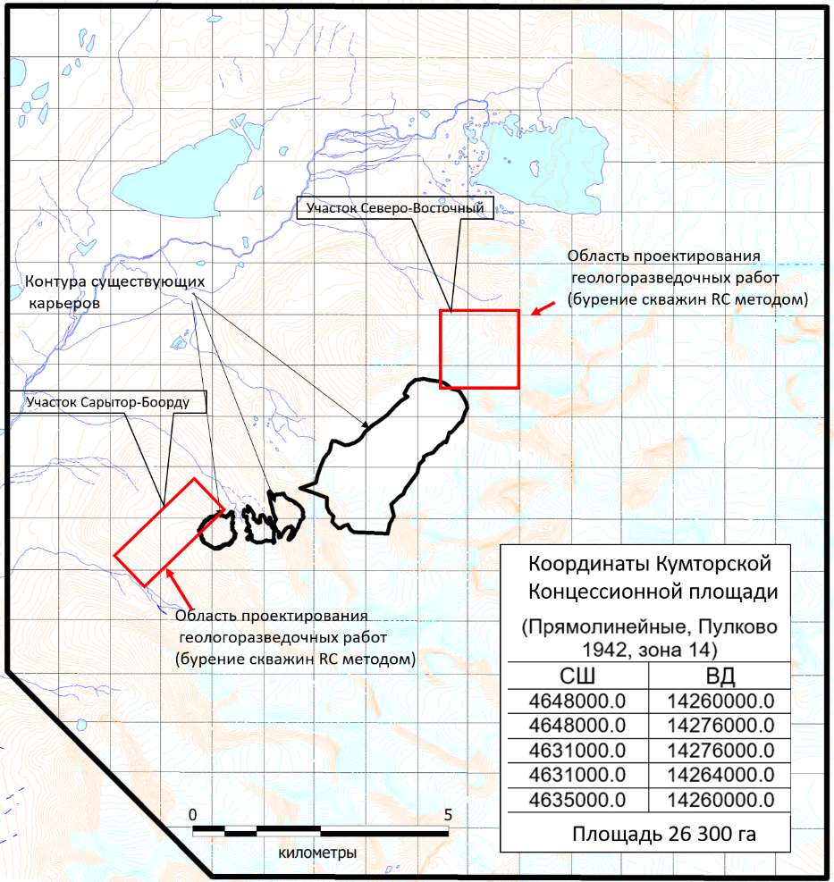
Turnaround time:
Beginning of operations: - April 2019
Completion of operations: - December 2019

