Terms of Reference

to perform well installations reverse drilling (RC-drilling) at the Kumtor concession area in 2019

The basis of the work: Availability of a revised concession agreement between the Government of the Kyrgyz Republic and Kumtor Gold Company CJSC of June 6, 2009.

Special purpose:
- Exploration and geological exploration at the Sarytor-Boordu and Northeastern areas.

Spatial location of the object:
- Kumtor area is located in the Jety-Oguz district of the Issyk-Kul region. The northwestern flank of the concession area (approximately 40% of its area) falls on the Kumtor inter-mountain depression filled with coarse quaternary sediments. The opposite southeastern flank of the territory extends to the high mountain (up to 5000 m) axial part of the Akshyirak ridge.
The nearest railway station, Balykchy is 230 km away and Bishkek is 410 km away.

1. The main parameters of the work:
Drilling operations (RC drilling) by installing WDH-500A, or its analogues.
A) Drilling wells depths of 200 - 500 meters. Drilling angles (dip) -90º. Diameter of drilling is 114-135 mm.
B) Inclinometer well - as needed.
C) The yield of drilling material is not less than 95%;
D) Sampling of 1.0m each with mandatory blowing/cleaning of the bottom hole and borehole;
E) Delivery of samples to the working area of the KGC exploration department.

Preliminary drilling volumes:
- 67 wells with a total drilling volume of the order of - 20 running meters km. (the cost of the work should be indicated in running meters taking into account the depths, subject to the performance of work by one drilling unit with a drilling capacity of about 120 meters per day).

The scope of work is not fixed and can be changed depending on the result.

Basic requirements when performing work

- Works must be carried out in strict compliance with applicable safety rules when conducting exploration works.
- Representatives of the Customer make inspections for compliance with safe conditions for conducting drilling operations in accordance with the safety rules during exploration.
Drilling operations are carried out by the Contractor, including mobilization/demobilization of their equipment, transportation of personnel, PPE and first-aid training in the Red Cross, organization of work at the sites. The Customer provides provision of living conditions and fuel.

Graphic application 1
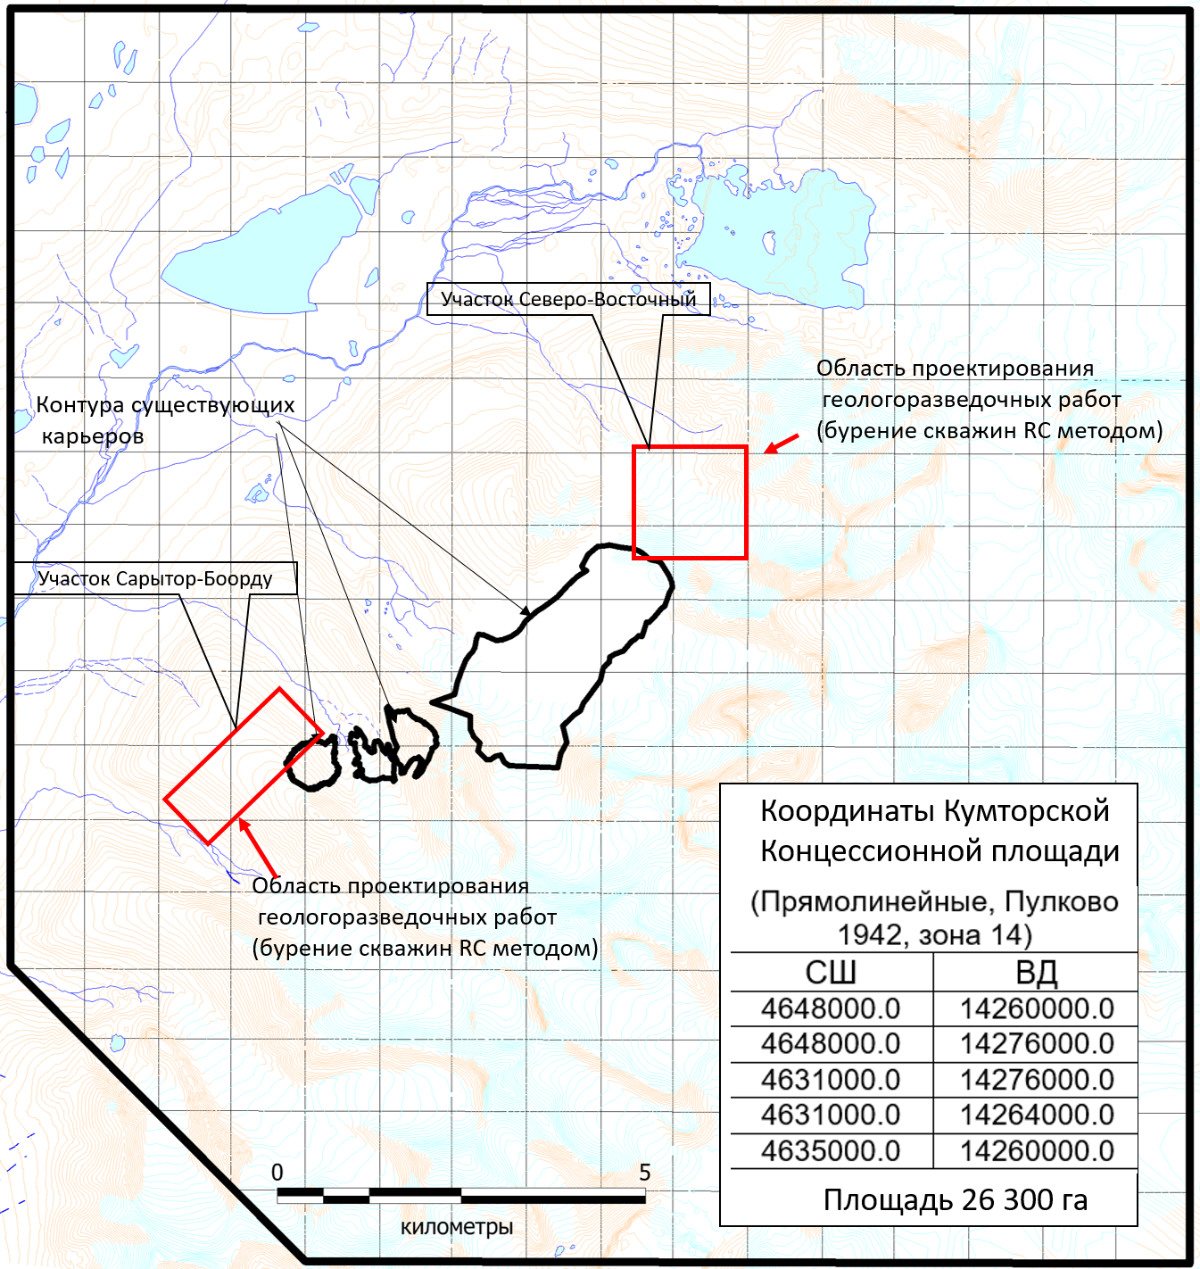
Turnaround time:
Beginning of work: - March 2019
Completion of works: - December 2019

