TERMS OF REFERENCE

to provide services during the performance of drilling operations
within the Kumtor Concession Area in 2018.

The basis for performing operations: The existence of the Revised Concession Agreement dated as of June 6, 2009 between the KR Government and Kumtor Gold Company.

Special purpose:
- Exploration work at the areas of the Kumtor mine.

Spatial location of the object:
- The Kumtor Mine Area is located in the Jety-Oguz District of the Issyk-Kul Region. The north-west side of the Concession Area (about 40% of its area) falls on the Kumtor intermountain hollow filled with coarse quaternary deposits. The opposite south-east side of the Area extends up to the high-altitude (up to 5,000 m) axial part of the Akshyirak Ridge.
The distance to the nearest Balykchy railway station is 230 km, distance to Bishkek is 410 km.

- KGC manpower for Drills
(LY50- 2 Drills, LF140 - 1 Drill):
## | Manpower | Number of manpower
1 | Drill Foreman | 2
2 | HSE Engineer | 2
3 | Drill operator | 12
4 | Assistant Drill operator | 24

The payment for services is calculated from the volume of drilling performed in running meters during the reporting month. The cost of vehicles must be included in the cost of the service.

Basic requirements for work performance

- The operations should be carried out in strict compliance with the existing safety rules during exploration operations.
- Representatives of the Customer shall carry out inspections to ensure that safe drilling conditions are complied with in accordance with safety rules during exploration operations.
The Contractor shall provide the manpower with transportation and accommodation at the working areas. The Customer shall provide with fuel.

Preliminary dates for completion of work:
beginning of operations: - June 2018
completion of operations: - December 2018

Graphical attachment 1
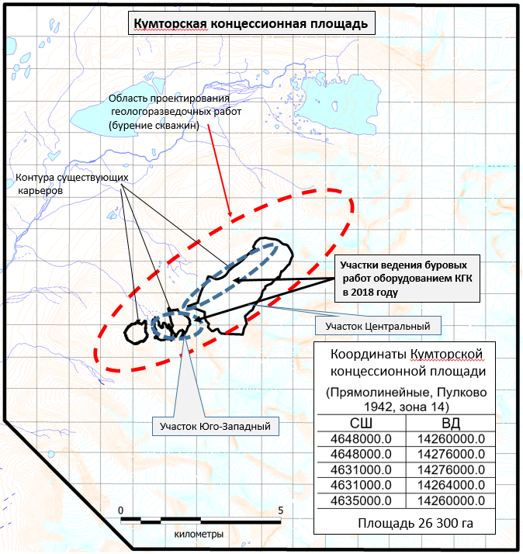
Area for design of exploration operations
(hole drilling)
Kumtor Concession Area
Contours of existing pits
Central Pit Area
South-West Area
Areas of drilling operations conducted by the KGC equipment in 2018
Kumtor Concession Area
Coordinates
(Rectilinear Coordinates, Pulkovo 1942, Zone 14)
Latitude
Longitude
Area of 26,300 hectares
kilometers

