TERMS OF REFERENCE

to perform drilling and related activities (construction of drilling sites, rehabilitation and construction of temporary roads) on the Kumtor concession area in 2018.

The basis for performing operations: The existence of the Revised Concession Agreement dated as of June 6, 2009 between the KR Government and Kumtor Gold Company.

Special purpose:
- Exploration work on the South-West and North-East sections.

Spatial location of the object:
- The Kumtor Mine Area is located in the Jety-Oguz District of the Issyk-Kul Region. The north-west side of the Concession Area (about 40% of its area) falls on the Kumtor intermountain hollow filled with coarse quaternary deposits. The opposite south-east side of the Area extends up to the high-altitude (up to 5,000 m) axial part of the Akshyirak Ridge.
The distance to the nearest Balykchy railway station is 230 km, distance to Bishkek is 410 km.

1. The main parameters of the work:
Drilling operations
A) Drilling of holes with depth of 200 - 900 meters. Drilling angles are 17-90º. Drilling (main) diameter is HQ.
B) Drillhole survey is made every 25 meters.
C) Core recovery is not less than 76% in the host rock, at least 90% in the ore zones. Core is packed into advance boxes. Each advance is tagged and recorded in the drilling log.
If the holes are damaged due to the fault of the Contractor and with the core recovery below 76% in the host rocks and below 90% in the ore zones, the Contractor will drill them again at their own expense.
The core of the emergency (damaged) hole is entirely provided to the Customer.

Preliminary amount of drilling operations:
- 30 holes will require about 12 linear km of drilling operations in total (indicate the cost of operations in linear meters provided that three drilling units operate 1800 meters per month in total).

2. Construction, rehabilitation of roads and construction of drilling sites:
- Road rehabilitation. Restore the destroyed sections of the existing road for the passage of haul trucks and passenger vehicles;
- Road construction. The width of the temporary road bed according to its topsoil for solid coating is not less than 3.5 meters; for icy coating is 6 m. The maximum longitudinal slope of the road is 7º (12.3%).
The total length of roads is about 10 line km with excavation of 120 000 cubic meters.
- Construction of drilling sites .. The parameters of the drilling site must be in compliance with the safety regulations for drilling operations and approximate to the standards of 13x20 meters. There will be 30 sites with the amount of excavation equal to 25 000 cubic meters.

The total preliminary amount of earthwork will make about 145,000 cubic meters.
The scope of work may be varied and can be changed depending on the result obtained.

Basic requirements for work performance

- The operations should be carried out in strict compliance with the existing safety rules during exploration operations.
- Representatives of the Customer shall carry out inspections to ensure that safe drilling conditions are complied with in accordance with safety rules during exploration operations.
The contractor shall provide drilling and other related operations including equipment mobilization/demobilization, transportation and accommodation of personnel at working areas. The Customer shall provide with fuel.

Graphical attachment 1
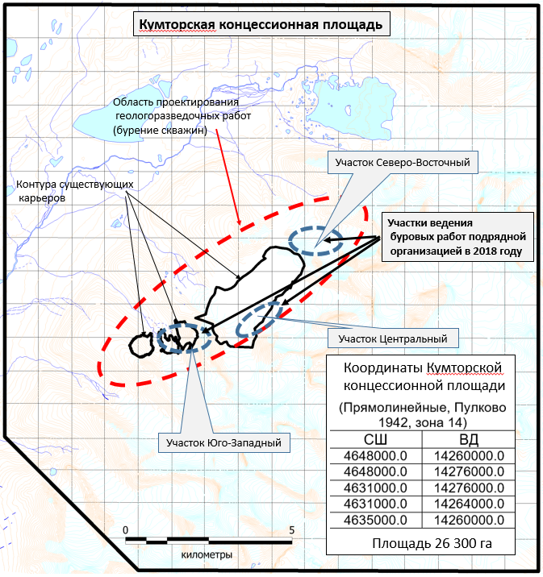
kilometers
Area of 26,300 hectares
Longitude
Latitude
Kumtor Concession Area
Coordinates
(Rectilinear Coordinates, Pulkovo 1942, Zone 14)
South-West Area
Central Pit Area
North-East Area
Areas of drilling operations conducted by the Contractor in 2018
Contours of existing pits
Area for design of exploration operations
(hole drilling)
Kumtor Concession Area
Work dates:
beginning of operations: - June 2018
completion of operations: - December 2018

