TERMS OF REFERENCE
to provide services during the performance of drilling operations within the Kumtor Concession Area in 2018.

The basis for performing operations: the existence of the Revised Concession Agreement dated June 6, 2009 between the KR Government and Kumtor Gold Company.

Special purpose:
- Exploration operations in the South-West and Central Pit Areas.

Mine site spatial location:
- The Kumtor Mine Area is located in the Jety-Oguz District of the Issyk-Kul Region. The north-west side of the Concession Area (about 40% of its area) falls on the Kumtor intermontane hollow filled with coarse quaternary deposits. The opposite south-east side of the Area extends up to the high-altitude (up to 5,000 m) axial part of the Akshyirak Ridge.
The distance to the nearest Balykchy railway station is 230 km, distance to Bishkek is 410 km.

- Services for operation of KGC drilling rigs
No. | Equipment with operator | Unit of measurement | Number
1 | Water truck (capacity -7-10 cubic meters). | vehicle | 4
2 | Sewage Truck (not less than 5 cubic meters). | vehicle | 4
3 | Vehicles for transportation of personnel and cargo (not less than 4 passengers and 1 ton of cargo) | vehicle | 2

Provision of the number of vehicles and personnel for the services for performance of related activities shall be agreed with the Customer and depends on the distances of the location of drilling sites. It is possible that the maintenance of closely located two drilling rigs will be carried out by one unit of vehicles.

The cost of work should be stated in KGS/km. In addition, the applicant has the right to indicate the cost of work in another unit of measurement.

Basic requirements for work performance

- The operations should be carried out in strict compliance with the existing safety rules during exploration operations.
- Representatives of the Customer shall carry out inspections to ensure that safe drilling conditions are complied with in accordance with safety rules during exploration operations.
Associated operations with hole drilling shall be performed by the Contractor. This includes equipment mobilization/demobilization, transportation and accommodation of personnel at work sites. The fuel shall be provided by the Customer.

Graphical attachment 1
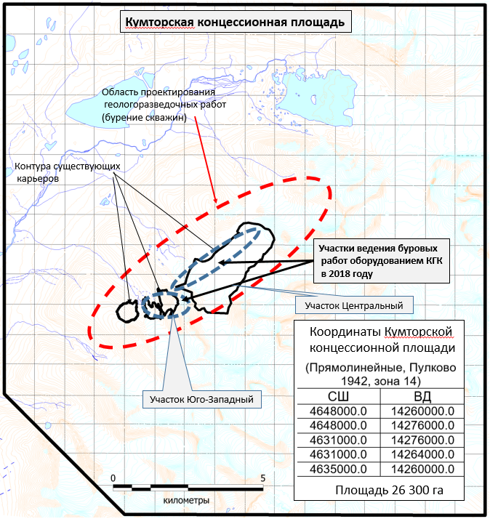
Kumtor Concession Area
Contours of existing pits
Areas of drilling operations conducted by KGC equipment
Area of 26,300 hectares
Longitude
Latitude
Kumtor Concession Area
Coordinates
(Rectilinear Coordinates, Pulkovo 1942, Zone 14)
kilometers
Area for design of exploration operations
(hole drilling)
Central Pit Area
South-West Area
Work dates:
beginning of operations: - June 2018
completion of operations: - December 2018

