# | Machine Description | Model | In service date | Manufa-red Year | Machine S/N | Tire Size | Hours
1 | SANDVIK MINING TAMROCK AXERA JUMBO 7-240 CABIN | MODEL 7-240 CABIN | February, 2008 | 2007 | 107D11861-1 | 12.00.R20 | 5935

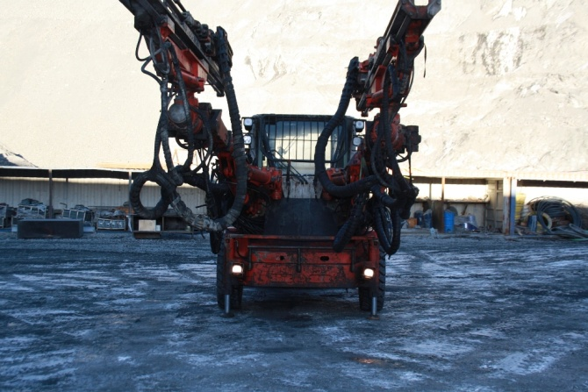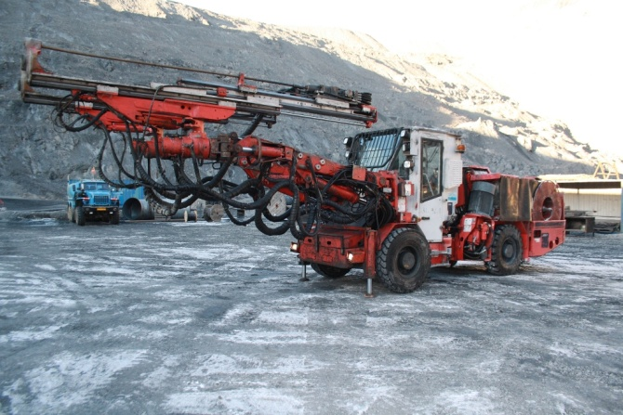
2 | SANDVIK JUMBO DRILL DD420-40C | DD420-40C | September, 2009 | 2008 | 108D12223-1 | 12.00.R20 | 4224

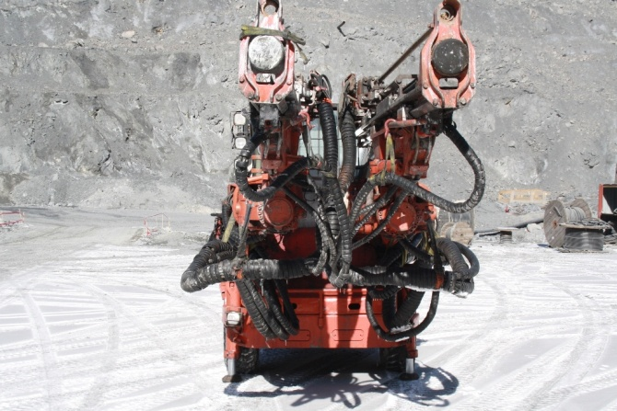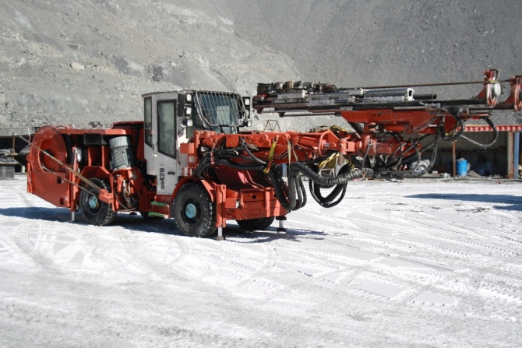

3 | SANDVIK JUMBO DRILL DD321-40C | DD321-40C | June, 2012 | 2011 | 112D19923-1 | 12.00.R20 | 204

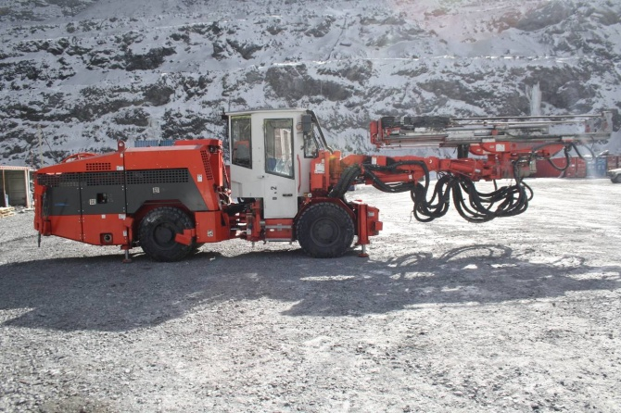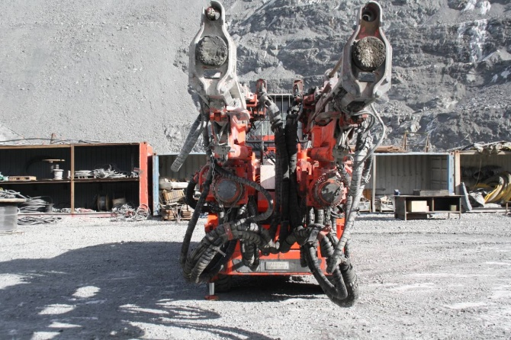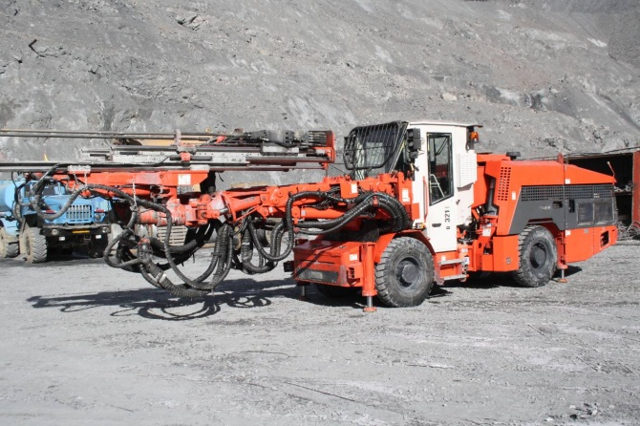

Spare parts for above Jumbo drill rigs

4 | UTIMEC LF 600 TRANSMIXER | LF600 | October, 2009 | 2009 | HE102 | 14.00.R24 | 4248

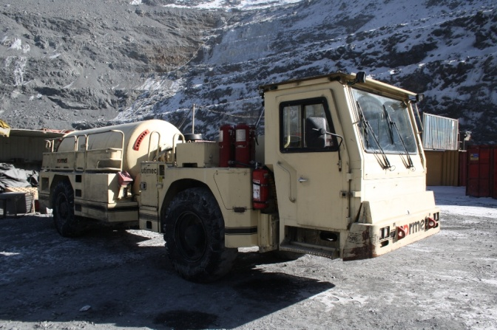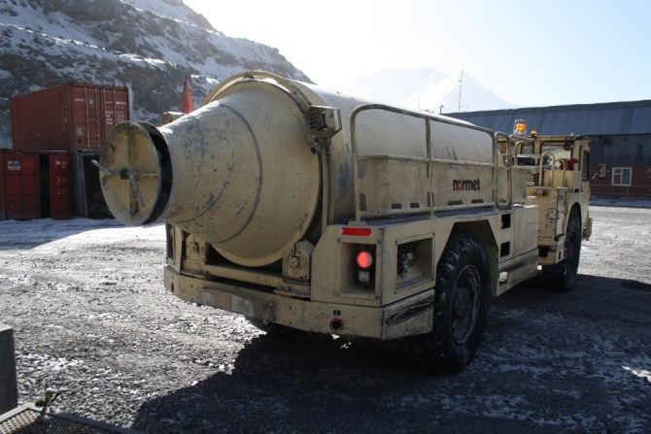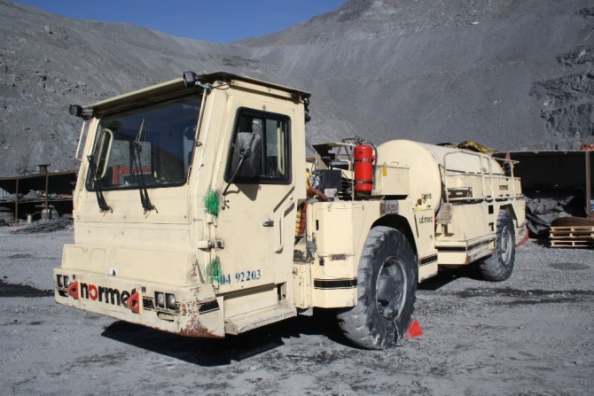

5 | UTIMEC LF 600 TRANSMIXER | LF600 | October, 2009 | 2009 | HE101 | 14.00.R24 | 6790

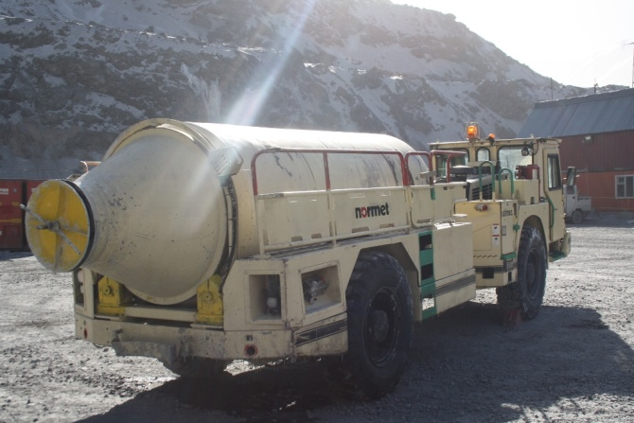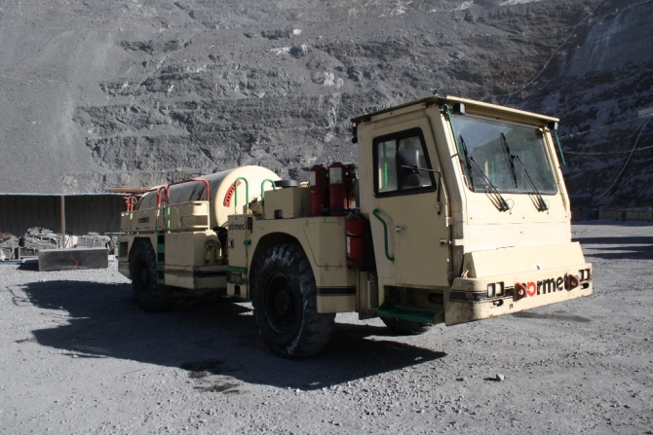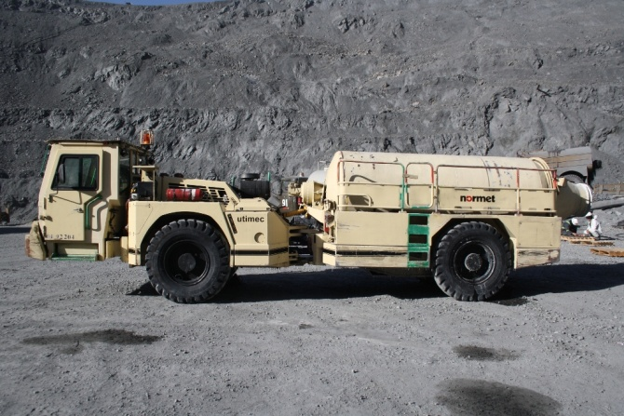

6 | UTIMEC LF 600 TRANSMIXER | LF600 | March, 2011 | 2011 | HE120 | 14.00.R24 | 1302

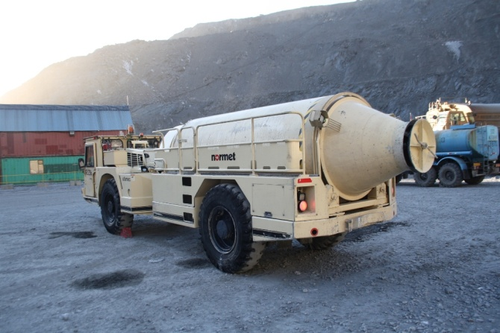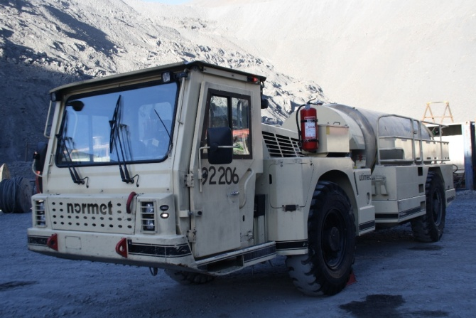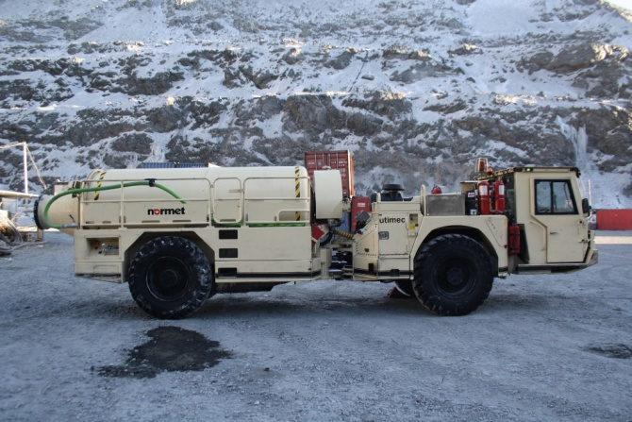
7 | UTIMEC LF 600 TRANSMIXER | LF600 | March, 2011 | 2011 | HE119 | 14.00.R24 | 5632

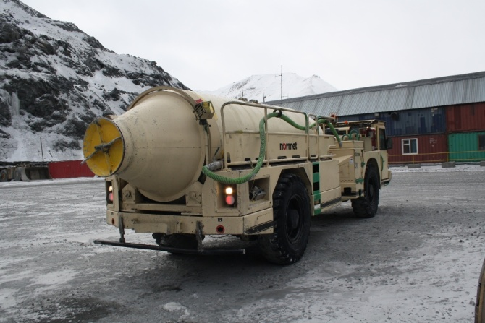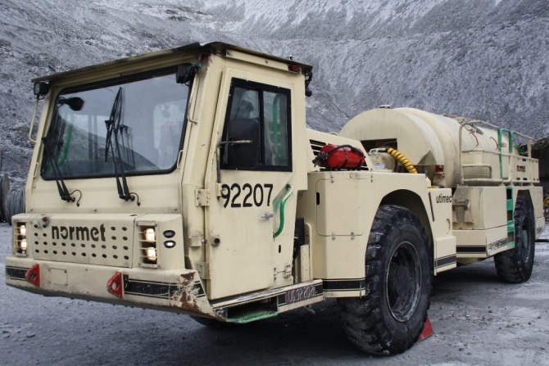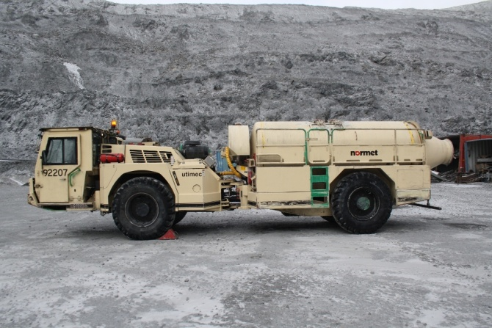
Spare parts for Normet UTIMEC Transmixers
8 | MINING TAMROCK ROBOLT 7 - 3 ROCK BOLTER | 7 - 3 CABIN | February, 2008 | 2007 | 107B12535-1 | 12.00.R20 | 850

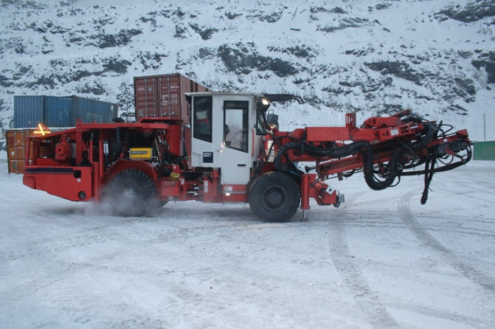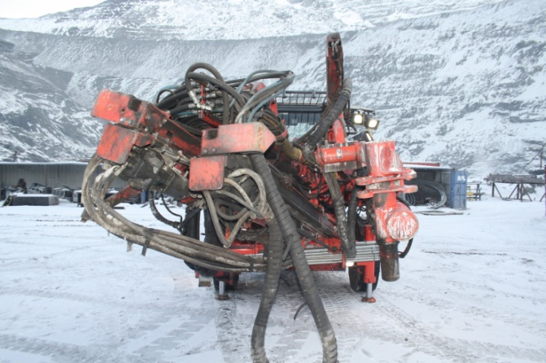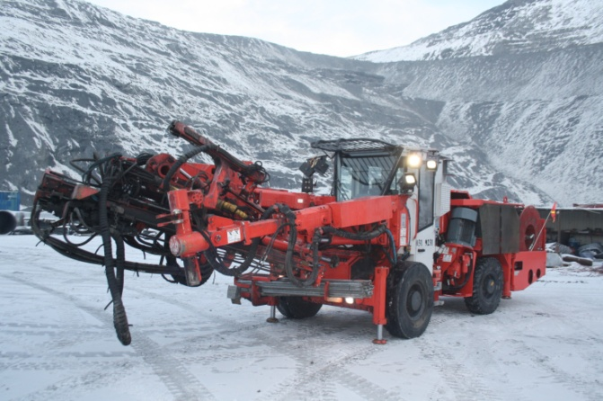
Spare parts for Sandvik Rock Bolter

9 | MINING TORO SCOOP T6 | T6 | February, 2009 | 2007 | 1706U183 | 17.5 R25 | 4450

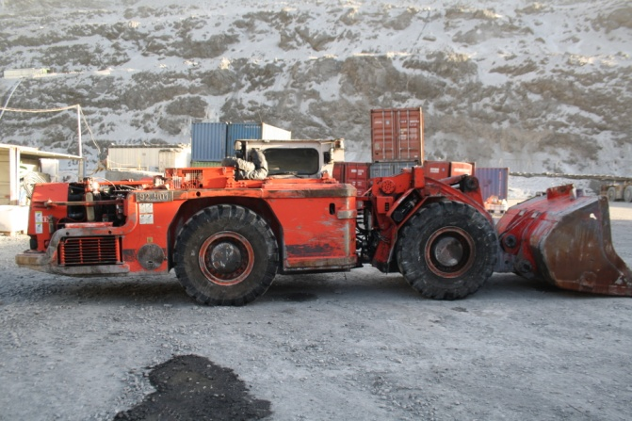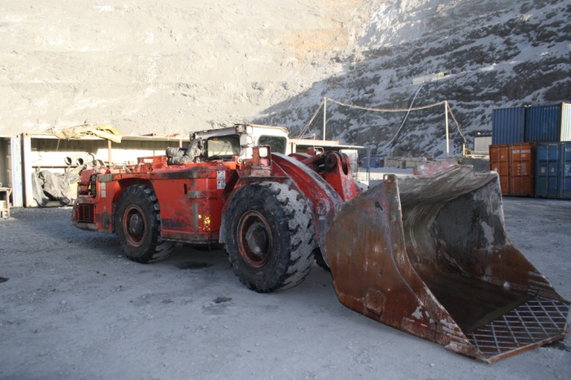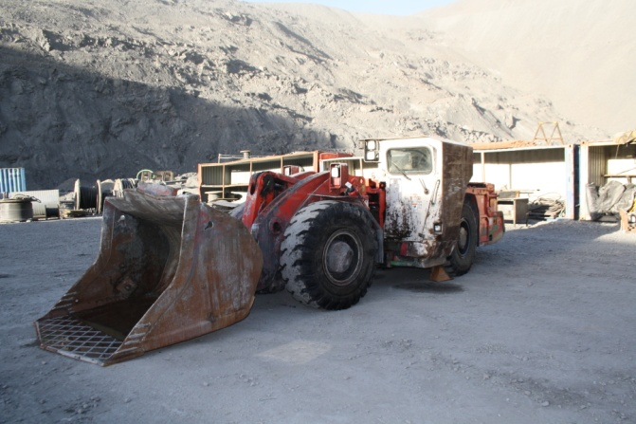
Spare parts for Sandvik Toro Scoop

10 | CATERPILLAR R1700G LOADER | R1700G | Setember, 2009 | 2008 | SBR00532 | 26.5 X 25 36 | 14480

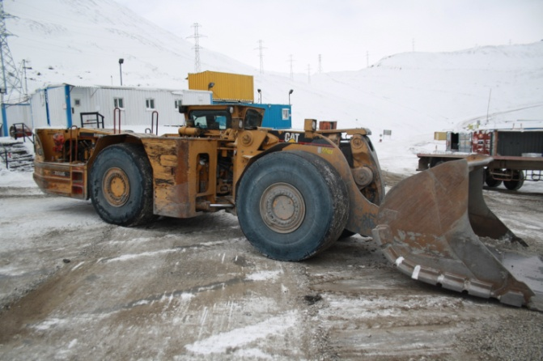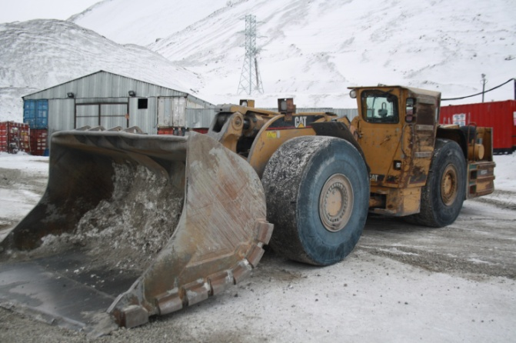

11 | CATERPILLAR R1700G LOADER | R1700G | Setember, 2009 | 2008 | SBR00735 | 26.5 X 25 36 | 14788

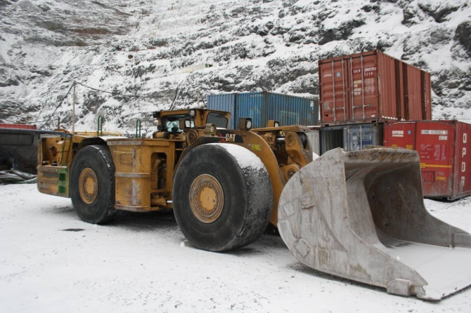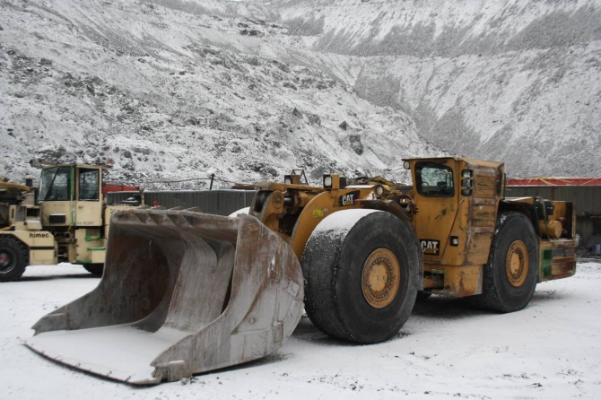

12 | CATERPILLAR R1600G LOADER | R1600G | November, 2011 | 2011 | 9YZ00719 | 18.00 R25 | 4093
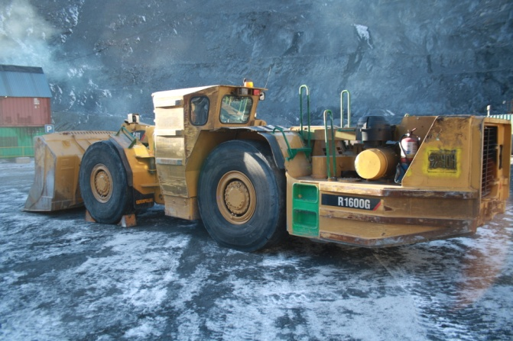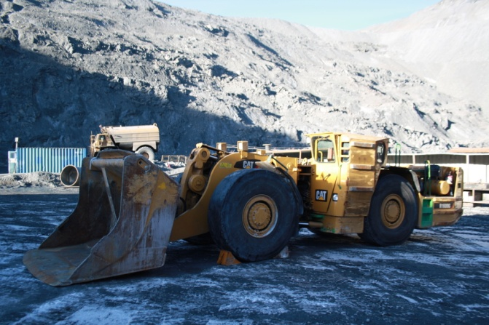
Spare parts for CAT Loaders – TBA
13 | SANDVIK MINING HAUL TRUCK EJC - 522 | EJC - 522 | February, 2008 | 2007 | 4279 | 18.00 R25 | 8310

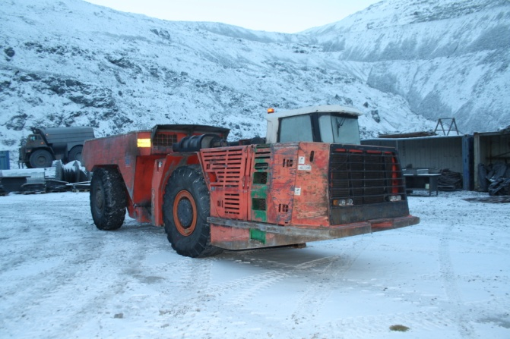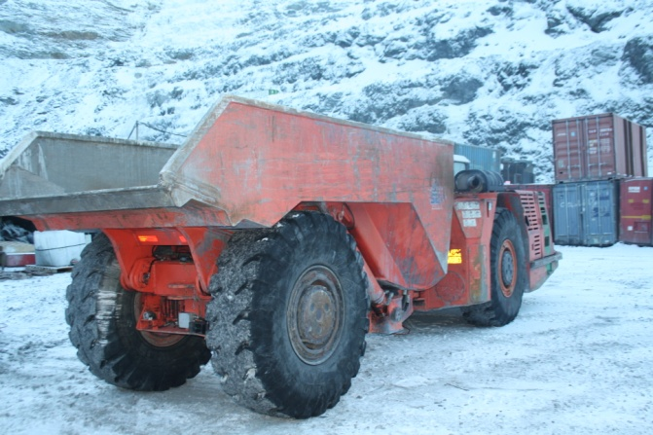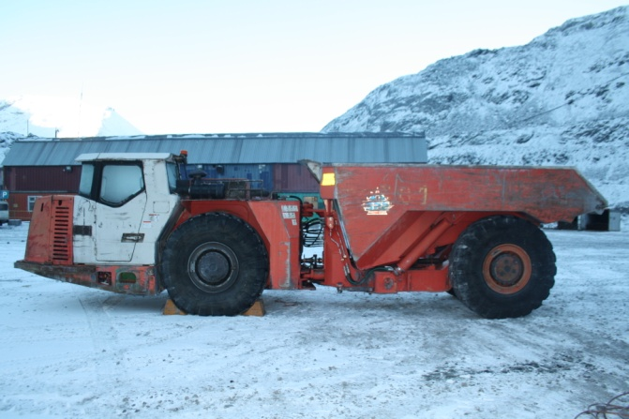
Spare parts for Sanvik Haul Truck
14 | CATERPILLAR AD45B UNDERGROUND MINING TRUCK | AD45B | September, 2009 | 2009 | CXM00420 | 29.5 X R29 | 10498

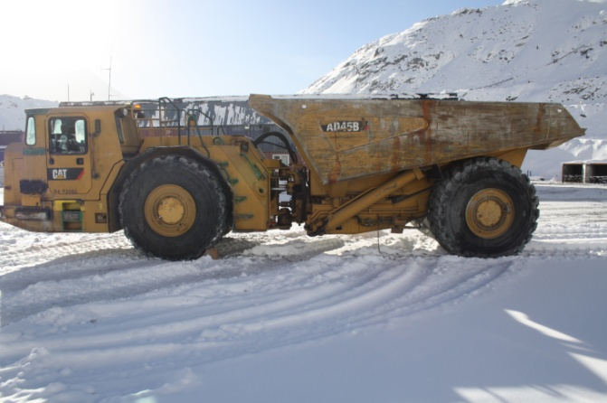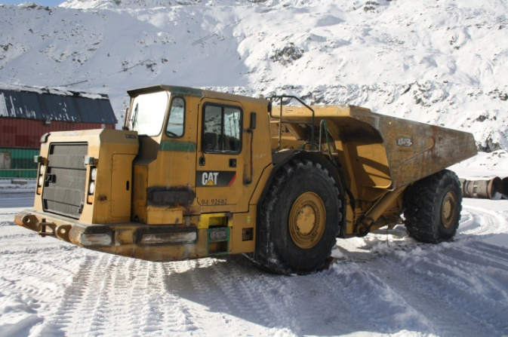
15 | CATERPILLAR AD45B UNDERGROUND MINING TRUCK | AD45B | September, 2009 | 2009 | CXM00425 | 29.5 X R29 | 10168

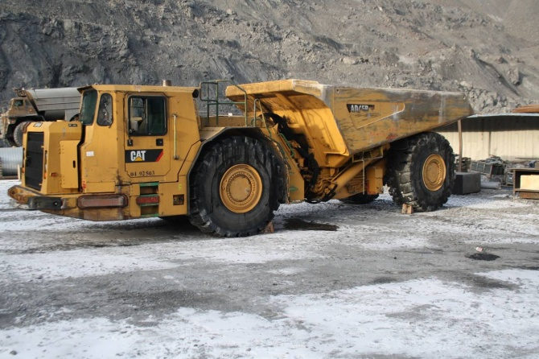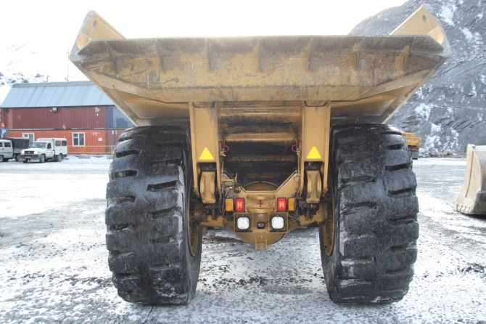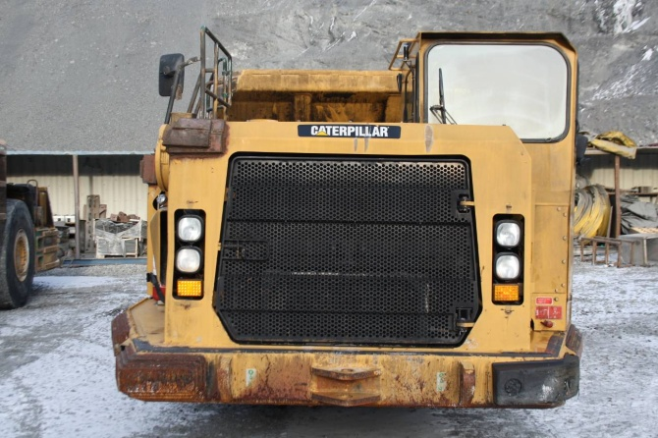
Spare parts for CAT trucks - TBA

16 | SANDVIK MINING HAUL TRUCK TH-320 | TH-320 | August, 2010 | 2009 | TH320-4563 | 18.00 R25 | 5790

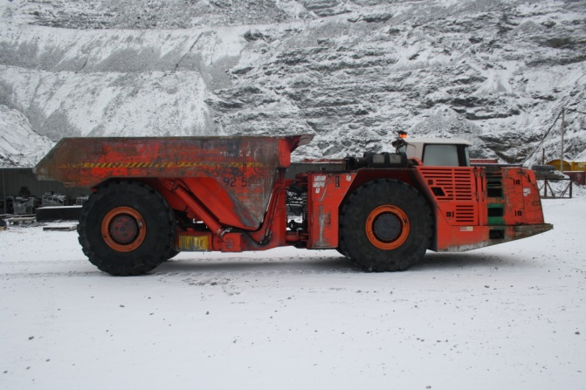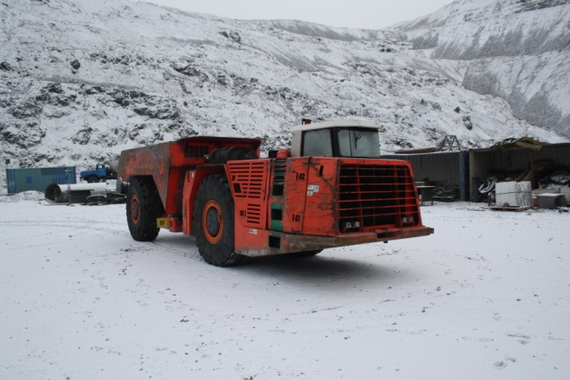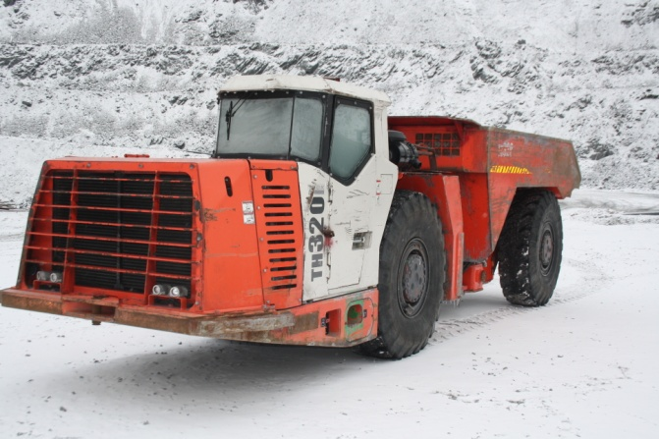
Spare parts for Sandvik TH-320 – please refer to the file for EJC-522 above

17 | NORMET SPRAYMEC 6050WP | 6050WP | September, 2009 | 2009 | 549 | 10.00.R21 | 5389

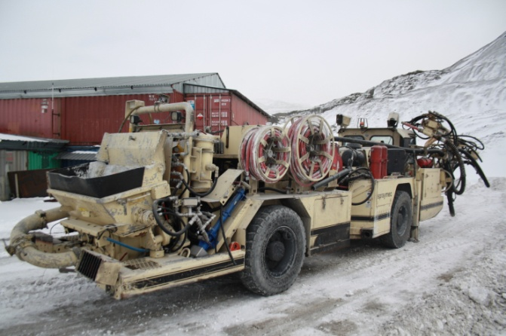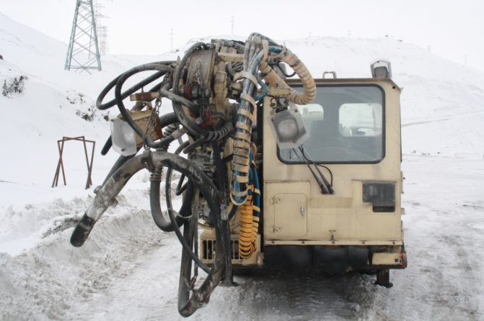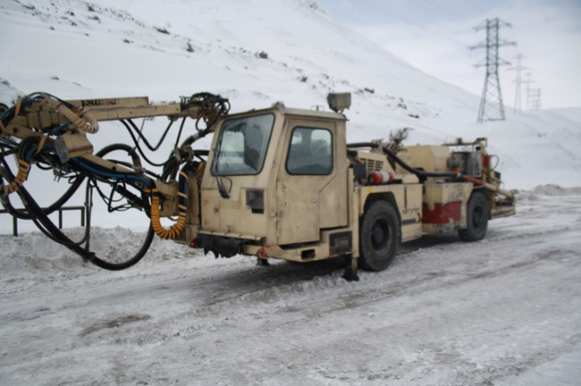

18 | NORMET SPRAYMEC 6050WP | 6050WP | September, 2009 | 2009 | 550 | 10.00.R21 | 6373

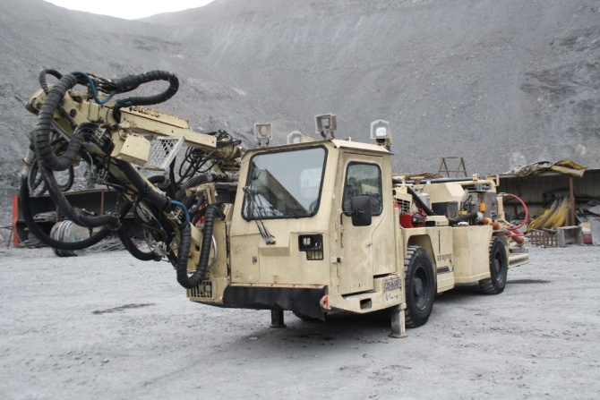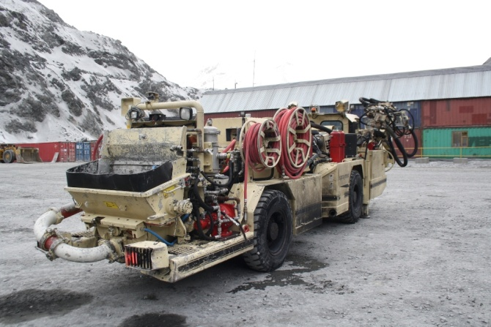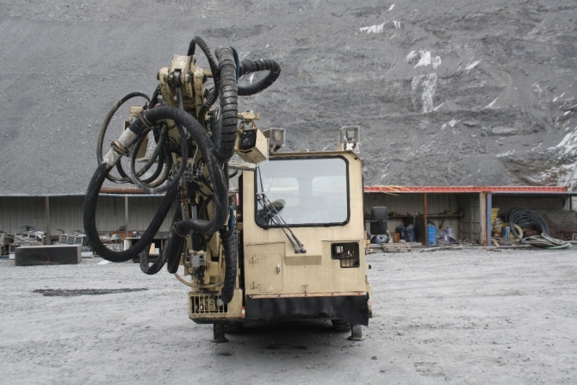
Spare parts for Normet Spraymec

19 | CHARMEC UTILIFT 6605BSN | 6605BSN | March, 2010 | 2010 | 564 | 12.00.R20 | 1352

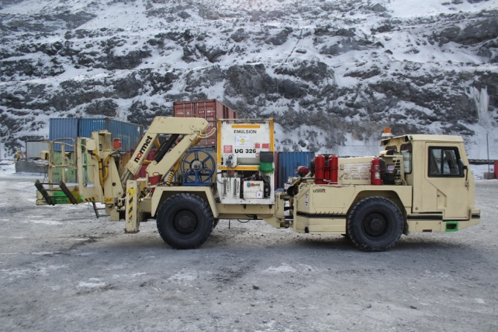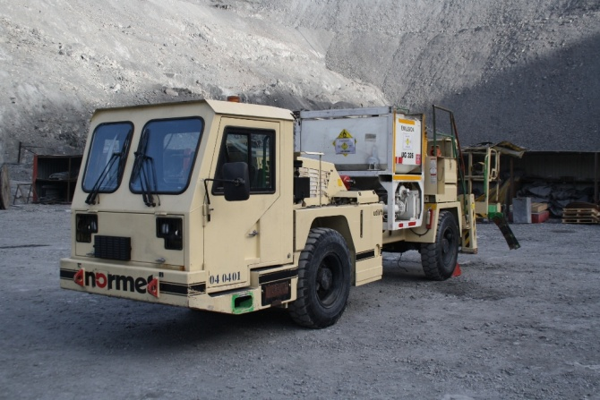
20 | CHARMEC UTILIFT 6605BSN | 6605BSN | March, 2010 | 2010 | 565 | 12.00.R20 | 5053

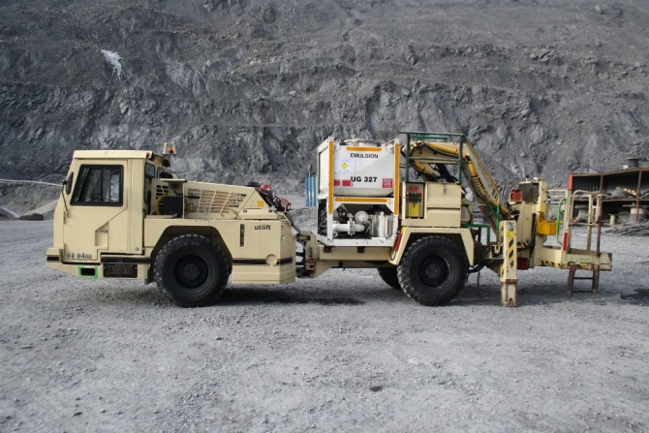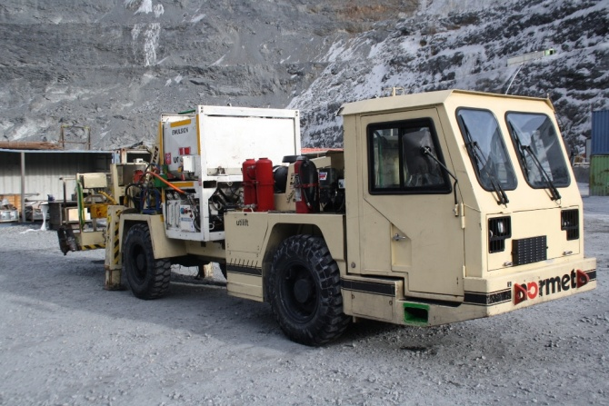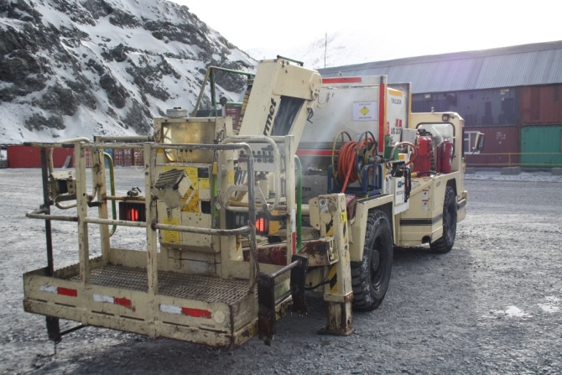
Spare parts for Normet Charmec Units
21 | Underground Motor Grader CAT 135H (Used) | CAT 135H | February, 2011 | 2005 | CBC00194 | 14.00.R24 | 7446
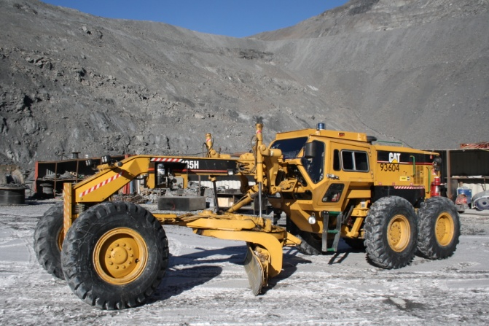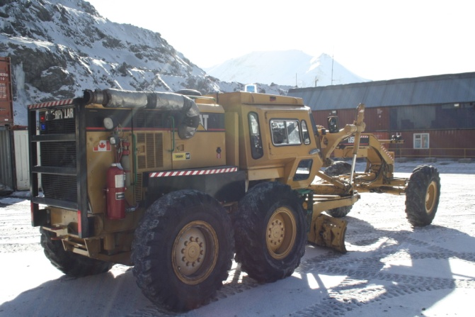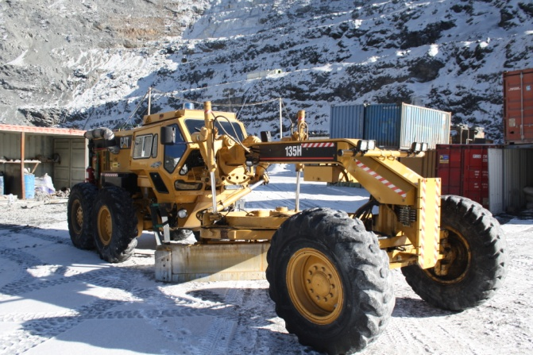
Spare parts for Grader - TBA
22 | MINECAT CABLE REELER MCE (New)  Parked almost right upon commissioning. | MC100E | August, 2012 | 2012 | N/A | N/A | N/A

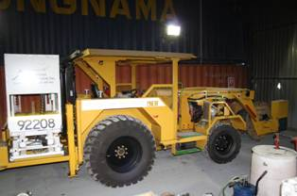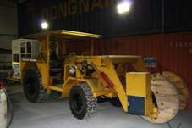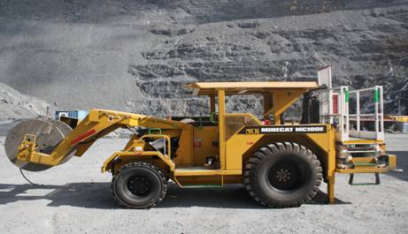
Spare parts for MINECAT Cable Reeler

